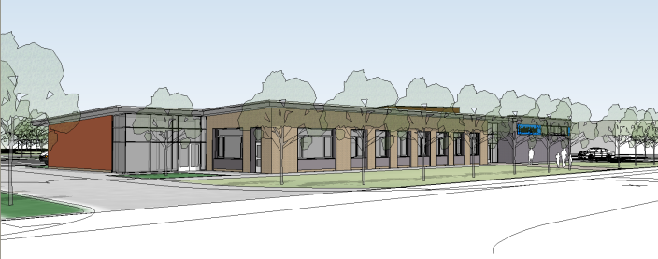
Policy for Sensory Integration and Modulation 2020
Background
Foxfield School is a mixed 11-19 school for pupils with severe learning difficulties.
The purpose of this document is to detail information on how Sensory Processing affects the pupils in our care and how as a school we support these pupils to access their learning and manage their behaviour.

Sensory Integration and Modulation.
Sensory Integration is about how our brain receives and processes sensory information so we are able to do the things we need to in everyday life. (Sensory integration network)
Sensory systems refer to Auditory, Tactile, Gustatory, Vestibular, Visual, Olfactory and Proprioception.
Due to the complexity of some of our pupils, many of them can be over responsive, under responsive or seek certain sensory systems; this can lead to displaying behaviours which could present in many different ways and occasionally in challenging behaviour. Sensory Modulation aims to provide pupils with supports so they are able to balance out their sensory needs and are able to be ‘just right and ready to learn’.

Assessment
Currently at Foxfield, the Sensory Co-ordinator works alongside Occupational Therapists from Shine Therapy. They look to target certain pupils across the school that may need support. These pupils are selected usually based on their level of engagement within school, displays of challenging behaviour and complex diagnosis after consultation with teachers, parents and outside agencies. The OT (Occupational Therapist) provides feedback and recommendations for specific pupils to the Sensory Coordinator who then works alongside teachers, parents and other agencies to train them and establish what are referred to as ‘sensory diets’. Additionally where needed the OT can focus on a whole class, feedback is then given to the Sensor y Coordinator who shares this information and helps to develop and implement additional support in class. Copies of the reports are given to teachers and parents.
Supports
We have a range of supports available throughout the school, including:
- ‘in class’ or individual supports
- sensory diets
- ‘engine rooms’
- Sensory circuits
All of these will use a range of equipment to support pupils.
Individual ‘in class’ supports.
These are examples of supports used by pupils at certain times in the day, or may be used to assist with regulation when changes have been made to their environment.
- Wobble cushions
- Ear defenders
- Lap weights
- Fiddle toys
- Chew toys
- Access to smells
- Light coverings
- Weighted vests
If the pupil has become passive a strategy may be used to make them more alert. If a pupil is anxious or stressed a strategy may be used to help them calm.
Sensory Diets
A number of pupils have ‘sensory diets’. These are individually designed programmes designed for specific pupils based on their particular needs. These are specific sensory activities that are given at regular intervals throughout the day and are designed to respond to pupils sensory needs and keep them well regulated. Depending on what is happening in the pupil’s day, or specific events in the pupil’s life at that time, the strategies may need to become more frequent or intense. We aim for sensory diets to be written by teachers with support from the Sensory Coordinator and to be shared with parents and outside agencies to ensure a consistent approach and support.

Use of Engine Rooms.
We have an engine room in school which can be accessed by all pupils. Here we have a range of equipment which can be used to support pupils.
Examples
- Rowing machines
- Gym balls
- Benches
- Spinning chair
- Weighted bean bags
- Weighted blankets
- Fiddle puzzles
- Balance beams
The engine room can be used for a variety of things including ‘sensory circuits’. These are used for pupils to regulate and order their senses. The rooms can also be used for calming or alerting activities and a place to carry out sensory diets. The room is available to all pupils throughout the day. There is information displayed for staff any pupils to guide them in appropriate activities and safe use of the equipment.
Supporting Staff
Due to the complexity of the pupils at Foxfield staff have undergone sensory training. This has focussed on behaviours that may be displayed and how to support these. We have also looked at ‘sensory circuits’ and the use of equipment in the engine room. Training is essential for staff in this area and should be undertaken every two to three years.
For any further information please contact the school by phone, e mail or via your child’s Chat book.

