FOXFIELD SCHOOL

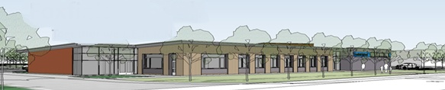

BEHAVIOUR POLICY

Updated 28/01/2020

WHOLE SCHOOL BEHAVIOUR LEADER
Becky Moffat

All other Foxfield School Policies should be taken into account when following the Foxfield School Behaviour Policy.

The Foxfield School Behaviour Policy works alongside, and may reference to the following policies;

- Calming Rooms Policy
- Communication Policy
- Moving and Handling Policy
- Rewards Policy
- Anti-Bullying Policy
- Sensory Policy
- Aromatherapy and Massage Policy
- Child Protection and Safe Guarding
- Health and Safety Policy
- Incidents and Accidents

CONTENTS
1 - AIMS AND EXPECTATIONS
- Aims of Foxfield School
- Foxfield School Mission statement
- Aims of Behaviour Management

2 - MULTI-PROFESSIONAL INVOLVEMENT
3 - DE-ESCALATION AND DIVERSION
- De-escalation and diversion strategies
- Staff to staff help script
- Staff to pupil help script
4 - SUPPORTING CHALLENGING BEHAVIOUR
- Positive Handling and Restrictive Intervention

5 - POSITIVE LISTENING AND LEARNING
6 - ASSESSING, RECORDING AND REPORTING
- Behaviour Management Plans
- Sleuth
- Communicating with Parents/Carers
- Reporting to Others
- Injuries to staff, pupils and others
7 – CALMING ROOMS AND CALMING SPACES
- Calming spaces
- Calming rooms
- Locking a calming room
8 – THE USE OF REINS, HANDLING BELTS AND VEHICLE HARNESSES
9 - BULLYING
10 – REWARDING GOOD BEHVIOUR
11 – GLOSSARY OF TERMS
12 - APPENDIX

‘Behaviour is a language……What is it telling us?’

AIMS AND EXPECTATIONS
All the issues outlined in this document must be seen in the context of the pupils individuals needs and the relationships that they have with those and the world around them. Any situations should be approached with the School Aims and Mission Statement in mind.

Aims of Foxfield School - (revised and updated Autumn 2013)
AIM 1
To enable all young people to achieve their full potential in all areas of their development.

AIM 2
To provide a happy, caring, stimulating, supportive, respectful and safe environment.

AIM 3
To work with everyone involved so that each young person in our school can become increasingly independent and integrate more successfully into the community.

AIM 4
To provide a broad and balanced curriculum relevant to the needs of every individual young person.

Foxfield School Mission Statement
“At Foxfield we L.E.A.R.N”
L – Life skills
E- Enjoyment
A – Achievement
R – Respect
N – New Experience
Aims of Behaviour Management
Behaviour management should be an integral part of the curriculum which teaches appropriate coping mechanisms and relevant social skills to all pupils, thus allowing them to participate fully in the life of their home, school/college and local community.
A behaviour management plan will be necessary for a variety of reasons, including the following:

- To ensure the safety and well being of that pupil.
- To ensure the safety and well being of members of staff, pupils or of the general public.
- To protect the environment.
- To protect pupils from self-injury or injury.
- To divert pupils from inappropriate to appropriate behaviour.
- To teach pupils to have self-control, and subsequently to take responsibility and be accountable for their actions.
- To teach pupils a ‘better way’ or more desirable behaviour.
- To teach pupils that actions and choices have consequences.
- To allow pupils to develop and demonstrate positive abilities and attitudes.
- To communicate the pupils’ behaviours and levels of emotions with others.
- To have a consistent proactive approach to support pupils’ behaviours and emotions.

It worth remembering that many pupils cannot devise strategies themselves for managing difficult situations or addressing their challenging behaviours due to a lack of emotional intelligence. It may fall to the adults around them to devise and implement these strategies as a part of meeting the pupil’s needs.

MULTI-PROFESSIONAL INVOLVEMENT
The majority of pupils who require support to develop their behaviour will have other services involved with them. If they have not, consideration should be given at the outset as to who should be alerted and invited to contribute to discussions on how to respond to and manage challenging behaviours. The school will undertake to coordinate this work.
All professionals and others (family members, etc) will be encouraged to contribute and take part in any meetings that are held. However, as these can be working groups extending over a period of time, commitment must be given and attendance restricted to those directly concerned. The idea may be to establish a stable group of people who will attend a number of meetings that are held to review strategies.

DE-ESCALATION AND DIVERSION
The aim of a de-escalation and/or diversion strategy is for staff to positively intervene at an early stage to prevent a pupil/pupils going into crisis.
At Foxfield staff have a wealth of de-escalation and diversion strategies that are used on a regular basis to prevent pupils going into crisis. These may often be carried out and go unrecognised by others. These strategies may not be used on the pupil directly, they may be used on peers in order to have the desired effect on a target pupil. More than one strategy may be used. Strategies may be used in a specific order, at specified times of day or by specified staff/environments. It is important that there is consistency in order for pupils to learn a more appropriate way of coping with and expressing their behaviour. All of this information will be recorded in the pupils Behaviour Management Plan. Strategies must be used to take into account the pupils’ physical, cognitive and communicational needs. It is important to remember that what works with one member of staff or one pupil will not necessarily work for another member of staff or pupil.
For examples of de-escalation strategies used at Foxfield School see Appendix 5
Help scripts
Help scripts are set phrases which are used at the start, during or after an incident for staff to communicate effectively and calmly with either each other or with the pupil. Help Scripts also to establish a consistent language with the pupils during times of support.

Staff to staff help script
It is a sign of professional courtesy to offer help and allow the recipient to choose what sort of help they require. But there are also occasions when the member of staff involved is not best placed to make the decision. Other things maybe happening that they are not aware of. Alternatively, they may be getting tired or upset without realising it. This is where the ‘More Help’ script is important. Changing face can often save face for at least one of the parties locked into a battle of wills.
The words should function like a flashcard.

Offer: “Help is available.....”
Response: “You can help by....”
Offer: “More help.....
Response: “What do you suggest?”

Example:

Offer: “Help is available”
Response: “You can help by getting me a drink for John”.

Or

Offer: “More help....”
Response: “What do you suggest?”
Offer: “I suggest you have a phone call to make and I will help John”.

The person offering helping needs to give clear direction and the member of staff can get out with dignity.

Staff to pupil help scripts

When being confronted with an incident and having carried out a dynamic risk assessment, it is essential that words are selected carefully. The use of a script can help the member of staff appear calm, ready to listen and does not imply that the pupil is in the wrong. Therefore, with this positive approach it is likely to have a positive outcome. It also gives the member of staff time to continue assessing the situation and make a plan of action.

Staff: “John…..I can see something has happened....”
Pause for silence
Staff: “I’m here to help....”
Pause for silence
Staff: “You talk and I’ll listen...”
Pause for silence

Ensure that; the pupil’s name is used in order to make them the priority, body language is open, both parties are in social space and give plenty of time for the script to take effect. Repeat if needed. This can also be used for non-verbal pupils as the script naturally creates a positive, calm atmosphere.

Staff: “I care enough about you not to let you loose control”.

Staff should also carry out positive listening and learning so that pupils develop their emotional literacy skills and learn methods of identifying their emotions and needs and expressing them in a more appropriate manor. See Listening and learning section for more information.

SUPPORTING CHALLENGING BEHAVIOUR
“Children and young people did not say that people who had got dangerously out of control should not be restrained. Their concern was much more clear than that. It was that staff who restrain children should know how to do it properly.” (Roger Morgan. Children’s Rights Director 2004)
Positive Handling and Restrictive Physical Intervention
Section 550a of the Education act 1996 and DFEE circular 10/98 allow teachers and other members of staff at school who are authorised by the head teacher, to use such force as is reasonable in circumstances where the pupil may need to be prevented from engaging in behaviours which are likely to cause injury to themselves, others or damage property.
This guidance extends to maintaining good order and discipline for both on and off site activities.
Positive Handling should only be used in circumstances where all other strategies which do not employ force have been tried and found unsuccessful or in an emergency situation.
Team Teach Techniques are based on a gradual and graded approach using guides, controls and restraints. Staff must ensure that they select and apply a guide, a control or a restraint that is reasonable, proportionate and necessary and in the best interests of the pupil at all times.
- Guides – Used when there is minimal resistance from the pupil.
- Controls –Used when there is moderate resistance from the pupil.
- Restraints – Used when there is rigorous resistance from the pupil.

There is no legal definition of force. The criminal law act (1967) allows any person to use such force as is reasonable to prevent an offence (e.g. physical assault being committed). Reasonable force must be a matter of personal judgement.
All teachers have professional ‘duty of care’ within their jobs which is underwritten in paragraph 58.7 School Teacher Pay and Conditions Document 2009.
This framework is designed to enable two or more staff (Team Teach Tutors can use one person techniques until assistance is available) authorised by the head teacher to use force as they deem reasonable in order to prevent pupils from:
• Committing an offence
• Causing personal injury to, or damage to the property of, any person (including the pupil himself)
- Engaging in a behaviour which is prejudicial to the maintenance of good order and discipline of the school or among its pupils, whether it is during a teaching session or otherwise.
Examples of this could include:
- Pupils attacking a member of staff or another pupil
- Pupils putting themselves at risk by self-injurious behaviour or sensory seeking that may become too engrossing for their well being
- Pupils fighting
- Pupils causing or at risk of causing injury or damage by accident, by rough play or by misuse of dangerous materials, substances or objects
- Pupils causing damage to equipment/resources/meaningful belongings to themselves or others
- A pupil running in the corridor or stairway in a way which he/she might cause an accident likely to injure himself/others
- A pupil puts themselves at risk by absconding from class or trying to leave school
- A pupil persistently refuses to obey an order to leave a classroom
- A pupil is behaving in such a way that is seriously disrupting a lesson and education of themselves and others

Restrictive Physical Intervention
Restrictive Physical Intervention (RPI) is the positive application of force with the intention of protecting the pupil from harming themselves or others or seriously damaging property.
The proper use of Restrictive Physical Intervention requires skill and judgement as well as knowledge of the agreed non-formal methods of positive handling in place at Foxfield School that are appropriate to the individual.
The decision to use restrictive physical intervention must take account of:
  - In the best interests of the pupil – taking into account all the relevant circumstances
  - Must only employ a reasonable amount of force
  - Must be proportionate to the circumstance
  - Must be necessary - based on an assessment of risks associated with intervention compared with the risks of not employing physical intervention.
  - Medication/illness
  - Physical disabilities
  - Sensory impairments

Elevated risks when using Restrictive Physical Intervention
- Positional Asphyxia
- Pressure to the neck
- Prone holds
- Supine Holds
- Seated Holds
- Standing Holds
- Extreme Exertion
If at ANY point during RPI staff become unsure of the pupil’s breathing (including the pupil stating that they cannot breath) or feel that their medical situation has changed, staff MUST take IMMEDIATE ACTION and either release the pupil or modify the hold. This provides an opportunity to improve breathing or to re-engage if needed. This should be recorded and reported following the correct procedures.

Restrictive Physical Intervention at Foxfield School must not include;
- Hitting a pupil
- Deliberately inflicting pain on the pupil
- Deliberately preventing all movement
- Deliberately blocked pupil’s senses e.g. eyes, ears, mouth etc
- Restricting pupil’s breathing
- Contact with sexually sensitive areas
- Using techniques that staff are not up to date with regards to training
- Using non-Team Teach physical techniques
- Using objects with a primary purpose to assist with RPI
- Using force as a punishment

POSITIVE LISTENING AND LEARNING
Positive Listening and Learning is a separate part of the process aimed at rebuilding damaged emotions and relationships. This is not to be a forensic investigation to get the truth – in fact the wealth of research shows that very few investigations of human behaviour are successful in this regard. If both parties can come to an account of what happened that they can both live with that is good enough. This process is aimed at making things better for the future and to teach a better, more appropriate way.
At Foxfield we try our upmost to follow up after every incident. This needs to be appropriate to the pupil’s level of understanding and after an appropriate length of time has been allowed to suit the pupil. E.g. some pupils may require a few minutes, others a few hours, some a few days.
Again, the method in which the Positive Listening and Learning is determined by the pupils level of understanding. (Refer to Communication Policy). However, in all cases where staff have been involved in an incident they should try take the lead in rebuilding the relationship between themselves and the pupil/pupils involved through experiences that the pupil will find positive.
- Formal debriefing (different forms, see appendix for examples). Staff and/or pupils can complete these. A copy of these should be kept in the pupil’s file. This is planned.
- Formal or Informal ‘chat’ between staff and pupil
- Relationship rebuilding
- Formal/informal discussion between staff involved regarding how the incident was managed and what to change next time in order to teach a better way. Refer to de-escalation and distraction strategies.

When carrying out Positive Listening and Learning it is important that the following factors are taken into consideration;
- TIME: There can be no hard and fast rule about choosing the right time. Listening and learning can only begin when the pupil is ready. It cannot be forced. Staff should ensure that there is sufficient time for the process so that it will not feel rushed.
- ENVIRONMENT: The choice of environment should be a comfortable and neutral area where you will not be disturbed. Staff should try to ensure seating is at the same height and there are no artificial barriers.
- LISTEN: Part of active listening involves looking at body language and trying to establish rapport – “listen with your eyes”. Listening should be non-judgemental to obtain the fullest appreciation of the pupils account of what has happened. A member of staff can then help the pupil to learn from that incident.
When using the de-briefing cards they have different formats however the structure and purpose remains the same. Following the acronym of HELP.
H: Hear the individuals’ story first and try to listen to the feelings as well as the words.
E: Explain why the member of staff had to take the actions they did. Use “I” language to explain that we have a duty of care to keep people and property safe, why the actions were in the pupils’ ultimate best interests.
L: Link the feelings of the pupil with the behaviour. Separate the person from the behaviour.
P: Plan together to find a better way of dealing with similar emotions in the future. What can both staff and pupils do differently to reduce the chance of repetition?
Examples of debriefing resources can be found in Appendix 3.

ASSESSING, RECORDING AND REPORTING
Behaviour Management Plans
The purpose of a Behaviour Management Plan at Foxfield is to communicate the best strategies for the individual to help them deal with their behaviours, emotions and sensory needs in a consistent, safe and appropriate manner.
At Foxfield School the majority of pupils have a Behaviour Management Plan as we acknowledge that all pupils have emotions and express these in a variety of ways. Ultimately we aim to teach pupils how to express their emotions in an appropriate way and therefore developing into emotional literate individuals who can deal with their emotions themselves and in an appropriate manor. For some individuals becoming emotional literate is an unrealistic target and we aim to teach these pupils emotional literacy skills in order for them to identify their emotions and develop appropriate coping strategies to deal with them.
Taking this into account, some pupils will have a very detailed Behaviour Management Plan, where as other pupils who have made good progress and have a reasonable level of emotional intelligence may have very little on their plan.
It is also important to bear in mind that some pupils (particularly pupils with ASD) will seek some form of sensory input and if this need cannot be fulfilled may result in a display of inappropriate behaviour. Or the actual sensory input the pupil is seeking may be inappropriate itself. Therefore staff need to support the pupil to find more appropriate sensory stimulation and methods of communicating the need for this in order to develop appropriate coping strategies. In these instances information may also be found on a pupil’s sensory diet plan (only used for some individuals). (See Sensory Policy)
The plans are updated a minimum of twice each academic year. However, it is working document that should be updated as and when, dictated by any new/changes in behaviour that the pupil demonstrates or new/changes in strategies used to support the pupil.
The plan indicates what a pupil looks like when they are calm and ready to learn. When they are happy and excited. These are what we hope to see for the majority of the time for most pupils while they are in Foxfield and beyond. However, some pupils present more challenging behaviours and staff need to manage these circumstances safely and consistently. The Behaviour Management Plan paints a picture of what the pupil looks like during stages 1- 5 for their levels of crisis and what staff should do to respond in order to offer support that is reasonable, proportionate and necessary and in the best interests of the pupil at all times.
The Behaviour Management plan also contains information with regards to medical and communication factors in order to carryout debriefing that is at a suitable level of understanding for the pupil to learn a better way. The plan has suggested physical restrictive intervention techniques that should be tried or avoided to suit the individual. If a particular technique is too avoided, it does not mean to say that it cannot be beneficial in the future.
The plan also includes targets that should be realistic and meaningful for the pupil. The achievement of these targets can help to demonstrate progress. These targets can also be found on the pupil’s Individual Education Plan.
Parents/carers are encouraged to suggest strategies to complete these plans to adopt a consistent approach to addressing the pupil’s behaviour. All up to date behaviour management plans should be signed by a parent or carer where appropriate.
All classes have a hard copy of the pupil’s Behaviour Management Plans who are based in the class. Staff are asked to read these plans and follow them. There is also an electronic Behaviour Management Plan stored in the Student Files on the Foxfield School’s secure network. The electronic Behaviour Management Plans state whether or not the plan is signed or unsigned by parents or guardians.
Sleuth
Any incidents that require the use of restrictive physical intervention MUST be recorded on Sleuth, however, we encourage all disruptive and negative behaviours and any changes in behaviour to be recorded where possible. All staff have an individual username and password. It is their responsibility to remember and use their own password. If in the event staff forget their password, then they can seek a member of the Sleuth admin team to have this corrected. Sleuth can be accessed online and incidents can be recorded while off Foxfield School premises. However it is staff’s responsibility to ensure that the external access is secure and that they follow school policy and procedures. They must also remember to log off when reports are complete.
When entering incidents on Sleuth, it is important to have qualitative data rather than quantitative. Staff should follow the guidance given when completing reports (see appendix 6). Staff should ensure that all required boxes are completed and any relevant staff informed e.g. the Headteacher needs to be notified of the use of any ground holds, but no other notifications should be forwarded unless it is agreed in advance.
If staff feel that Sleuth functions need updating e.g. new behaviours, new subjects, new locations to be added please seek a member of the Sleuth admin team.
Sleuth data is very useful to identify patterns, increases and decreases in incidents, levels of behaviour, staff and pupil conflict etc. This information should be used proactively and help to plan for the future in order to reduce incidents, the length of incident times, and the length of time spent in restrictive physical intervention and injuries to staff and pupils. The data can be presented in graph form and should be used during multi-discipline meetings, medical reviews, annual reviews, and to support Individual Education Plan targets where appropriate. Governors and others can view the information if the head teacher deems it appropriate.

If for whatever reason Sleuth is not working, a new pupil has started and not yet on the system or a pupil from another school is in Foxfield and has an incident involving restrictive physical intervention then a ‘Bound and Numbered Book’ must be used to record the incident. A bound and numbered book can be found in the school office. If this incident is then added to Sleuth at a later date it is essential that staff mark on the incident page in the bound and numbered book that it is now on Sleuth. All data must be kept for a minimum of 25 years.

Communicating with Parents/Carers
As well as the Behaviour Management Plan being communicated with parents/carers, it is good practice that the use of any restrictive physical intervention is communicated on the day it occurred; this can be done by phone call, email or message in a chat book. This is the responsibility of the class staff. On some occasions, pupils who require the use of regular restrictive physical intervention it may be more appropriate to only communicate any different or ‘out if the ordinary’ incidents. This should be agreed with parents in advanced.
In some cases it may be more detrimental to the pupil to inform their parents/carers of an incident in school and if this is the case staff should seek out the ‘Child Protection Officer’ for advice. All of these circumstances involve the staff having a good knowledge of the pupils they work with and some background information of their home life in order to communicate appropriately.
Reporting to Others
On an eight week basis, the number of ground holds used at Foxfield School get sent to both George Matthews (head of Team Teach) and the Health and Safety Officer for Wirral.
Sleuth data may be used during medical and/or Multi-disciplinary meetings where specific matters may be discussed involving staff outside of Foxfield School.
Injuries to staff, pupils and others
“Team-Teach techniques seek to avoid injury to the service user, but it is possible that bruising or scratching may occur accidentally, and these are not to be seen necessarily as a failure of professional technique, but a regrettable and infrequent side effect of ensuring that the service user remains safe”. (George Matthews - Director)
If a member of staff is injured during an incident then they should leave the incident as soon as is safe to do so to seek medical advice from a first aider. A first aider will complete a medical form (this must not state refer to Sleuth for what happened). The injured member of staff must also complete an accident at work form and get it signed by the Health and Safety officer. A copy of this form must be obtained by the injured member of staff and a copy placed in the pupil’s file who inflicted the injury. Any injuries to staff must also be recorded on Sleuth during the reporting of the incident. It is the decision of the Health and Safety Officer and the injured member of staff as to whether or not the injured member of staff is fit to continue to fulfil their job requirements for the day.
If the pupil themselves gets injured whether it be during restrictive physical intervention or from self-injurious behaviour in addition to Sleuth and the first aid form, complete; an accident (need 4 copies, 3 for Deputy, 1 for injured pupil file) and inform parents.
If a pupil is injured by another pupil; in addition to Sleuth and the first aid form complete an accident (need 5 copies, 3 for Deputy, 1 for injured pupil file and 1 for the pupil who caused the injury file) and inform parents of injured pupil and the parents of the pupil who caused the injury if necessary.
Staff member gets injured by a pupil or during an incident; in addition to Sleuth and the first aid form complete; 1 accident (need 5 copies, 3 for Deputy, 1 for the member of staff and 1 for the pupil who caused the injury file).
If a non-staff member/visitor to the school gets injured; in addition to Sleuth and the first aid form complete; 1 accident (need 5 copies, 3 for Deputy, 1 for the member of staff and 1 for the pupil who caused the injury file). Contact the supply agency if necessary.

Calming Rooms and calming spaces
The DCSF Building Bulletin 102 states that
‘These small rooms are used to help children calm down. Good sight lines, health, safety and welfare must be ensured. A pleasant calm space is needed. Materials, fittings and finishes should safeguard against self-harm’ (p 116)

Calming spaces
Foxfield has a number of spaces on the school grounds (inside and outside) that can be used with the purpose of calming a pupil/pupils. These are not designated areas, however, if spaces are used for such purpose then it should be recorded using the correct procedures stating which environment was used. Some areas are more effective than others for calming pupils. Staff should also take into account other constraints e.g. the weather when using outside spaces, the times of day when using the playground as school transport could be moving. Calming spaces should be safe, quiet areas where pupils can relax and de-stress when needed, while being supervised from a safe distance by staff.

Calming rooms
Every classroom in Foxfield has an additional two rooms inside. One of which is built for the purpose of being a store cupboard for staff to use and the other is built to be flexible depending on the needs to the pupils whose classroom it is and will be decorated and furnished accordingly. E.g. small work room, library, sensory room, physiotherapy room, calming room etc. This provides facilities for pupils and staff to use when required that are in close proximity and can make incidents more manageable. These rooms all have windows to both outside and the classroom and one door to the classroom. It is the class teacher and team who decide how to use this small room that best suits the pupils’ needs. However, this can be overridden by the head teacher at any point.
For some pupils, particularly when they are upset, agitated or displaying aggressive and dangerous behaviours, close proximity to such a calming room is an advantage. Pupils can be directed to a room or escorted there by staff. On occasions this may require some form of restrictive physical intervention. Once the pupil is in the calming room however, they will be encouraged to relax, calm and stop any behaviours that may cause injury to themselves or others through appropriate de-escalation strategies according to their Positive Behaviour Management Plan.
Pupils who are taken to a calming room will always be constantly and closely supervised by one or more staff. The staff will use de-escalation techniques and effective communication to try to defuse the situation and bring the incident to a close. Their aim will be to get the pupil to behave calmly and safely as soon as possible so that they may re-join their peers and participate in normal school activities.
Any pupil who behaves in such a manner as to need to spend time in a calming room would have a Behaviour Management Plan. The circumstances that required the room to be used and the reasons for this would be considered when the plan was devised, reviewed and updated. The plan must be shared with the parents or carers. Where use of a calming room was built into a pupil’s plan it should specify what staff will do in the room, why the pupil would be taken there, how long a pupil should spend there and the exit strategy (including positive listening and learning).

In instances where the small room is used, at any point with the purpose of being a calming room, staff must try to ensure that the room is free from materials, fittings and finishes that could cause self-harm where possible.
If pupils choose to use the calming room and take themselves there, they have the option to close the door or leave it open. They are unable to lock it and staff must observe them and support them until they are ready to resume.
Foxfield School currently has one room that is built with the sole purpose of a ‘calming room’ and is located just inside the pupils’ entrance to the school building to the right, opposite the hall.
If staff take the pupils into a calming room then staff should do one or more of the following;
- The door is open with no staff in the room but staff are in the main classroom to offer support and observed the pupil at all times.
- One or more staff in the room with no physical intervention is being used, with the door being open or closed.
- Two or more staff present in the room while restrictive physical intervention is being used, with the door being open or closed.
- No staff are in the calming room, the door is open and the pupil is being observed at all times by one or more members of staff.
- No staff are in the calming room, the door is closed by a member of staff but not held shut and the pupil is observed at all times.
If the pupil attempts to exit the calming room and it is not in their best interests or safe to do so in a current situation, then staff will need to use Restrictive Physical Intervention to take the pupil back into the calming room and remain in restrictive physical intervention for a reasonable and proportionate time depending on the pupils needs. Staff must follow the pupil’s behaviour management plan.

Locking a calming room
Foxfield School currently has one room that is built with the sole purpose of a ‘calming room’ and is located just inside the pupils’ entrance to the school building to the right, opposite the hall. This is the only calming room with a lock fitted. This lock remains deactivated through the general day to day running of the school. However, in emergencies when all other strategies have been exhausted then the lock can be activated. Staff should seek the Headteacher (or hierarchy of management if Headteacher is not on site). Discuss why it is reasonable, proportionate and necessary and in the best interests of the pupil to have the lock activated while outside agencies and/or parents/carers are contacted.
If the lock is activated a staff member must be standing in a position where they MUST observe what is happening in the room through the viewing panel in the door at all times. This locking facility allows a pupil to remain alone in the room safely to prevent a criminal action including assault, from taking place, while still being supervised by one or more members of staff. It prevents the constant need for staff to be in this room with the pupil, if the situation is such that there is a major risk of the pupil injuring the adult. If a pupil is alone in this room and the situation changed to one where the pupil was at risk of injuring themselves or if the isolation is causing severe distress to the individual then staff would immediately intervene. During this time when the lock is activated a plan should be put into place for the exit strategy.
A pupil’s behaviour management plan must be updated taking in account the circumstances and behaviours that were presented on the occasion they were held in the calm room with the lock activated so a plan is in place for a reoccurrence. The lock cannot be activated under the same circumstances again as it is no longer viewed as an emergency.

The locking device in this Calming Room would only be used when:
1. All attempts to prevent an assault on a member of staff or peer through the use of Restrictive Physical Intervention had proven to be unsuccessful or the pupil could not be held safely for example, medical reasons.
2. While the pupil was alone within the Calm room with the door locked they were constantly visible to the member(s) of staff outside the room. If at any point the pupil tried to avoid the gaze of staff by hiding behind seating, position themselves so they were not visible or turned the lights off staff would unlock the door and enter immediately.
3. When the pupil enters the room it will be explained in an appropriate way that they need to calm and be reminded of a more appropriate behaviour. If and when necessary they must be reminded of this throughout their time in the room
4. As soon as the immediate risk of assault decreases, staff must ensure that the lock is deactivated and the pupil is able to leave the room.

Under no circumstances will any pupil at Foxfield be detained in a calming room or any other part of the school without constant staff supervision. The use of calming rooms by pupils and staff is kept under ongoing review with improvements in the planning and facilities being implemented wherever required.

The Use of Reins, Handling Belts and Vehicle Harnesses
At Foxfield School the use of reins, handling belts and vehicle harnesses are required at times. Some of this equipment can be used in supporting pupils that can demonstrate challenging behaviour. There are strict guidelines to the use of this equipment. Please refer to Foxfield School Manual Handling Policy for further details.

Bullying
Bullying is taken very seriously at Foxfield. Please refer to the Anti-Bullying Policy.

Rewarding Good Behaviour
We have a whole school Rewards system at Foxfield. Please refer to the Rewards Policy.
In addition to this many pupils have individual reward /working towards systems that support their Behaviour strategies positively. Timers are often used to give clear time indication to staff and pupils to balance pupil’s tolerance levels.

Glossary of Terms

Calming room: A separate space (maybe a smaller room) where the pupil can either choose to go or be taken to with the sole purpose to calm without the presence of other pupils. Pupils who are taken to a calm room must be observed and supported at all times until they are ready to resume. (See section 7)

Controls: The positive application of force to overcome moderate resistance, guiding and directing a person’s free movement. The purpose of the application should be to safeguard the pupil, other pupils and staff, to prevent significant damage to property and maintain an appropriate learning situation for all pupils.

Guides: The positive application of force to overcome minimal resistance promoting and encouraging a person’s free movement. The purpose of its application should be to safeguard the pupil, other pupils and staff, to prevent significant damage to property and maintain an appropriate learning situation for all pupils.

Last Resort: When other less intrusive options have been considered and judged to be ineffective or inappropriate.

Positive Handling: The full range of Team Teach strategies used to de-escalate, defuse and divert in order to prevent violence and reduce the risk of injury to pupils and staff, reduce damage to property and maintain an appropriate learning situation.

Reasonable: Proportionate to the circumstances it was intended to prevent in relation to the context in which the action was applied.

Restraints: The positive application of force by staff, in order to overcome rigorous resistance; completely directing, deciding and controlling a person’s free movement. The purpose of its application should be to safeguard the pupil, other pupils and staff, to prevent significant damage to property and maintain an appropriate learning situation for all pupils. The proper use of which requires knowledge, understanding, skill and judgement. All restraints should be recorded, monitored and reviewed.

Restrictive Physical Intervention: The use of force to control a person behaviour. It is used to restrict movement, restrict mobility and/or to disengage from dangerous or harmful physical contact and/or removing dangerous objects.

Seclusion: Forced to spend time alone against own will. (This requires statutory powers other than in an emergency)

Significant: A measure of degree or extent used to designate a cut-off point in judging seriousness of harm, physical intervention or restriction of liberty.

Timeout: Restricting positive reinforcement as part of a planned behavioural programme
(Requires written agreed plan)

Withdrawal: Removed from the situation but observed and supported until they are ready to resume

Violence: Any incident involving physical or verbal abuse of a threatening and/or racial nature, threat, fear or the application of force arising out of the course of their work.

APPENDIX

- Behaviour Management Plan

- Examples of Debriefing cards

- Examples of De-escalation and Diversion Strategies

- Sleuth Guidance

APPENDIX 1

Behaviour Management Plan

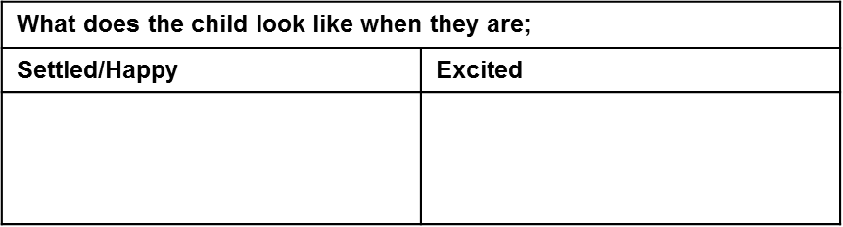
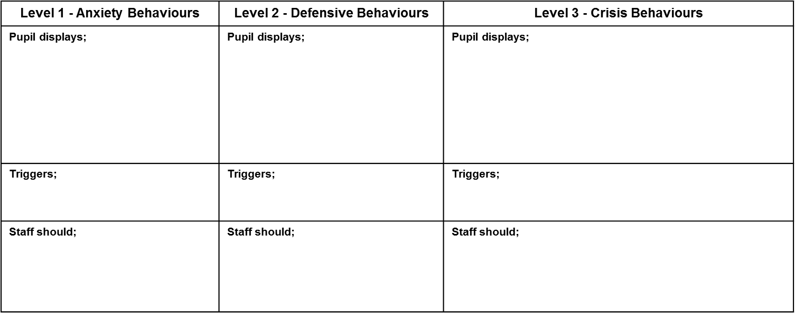
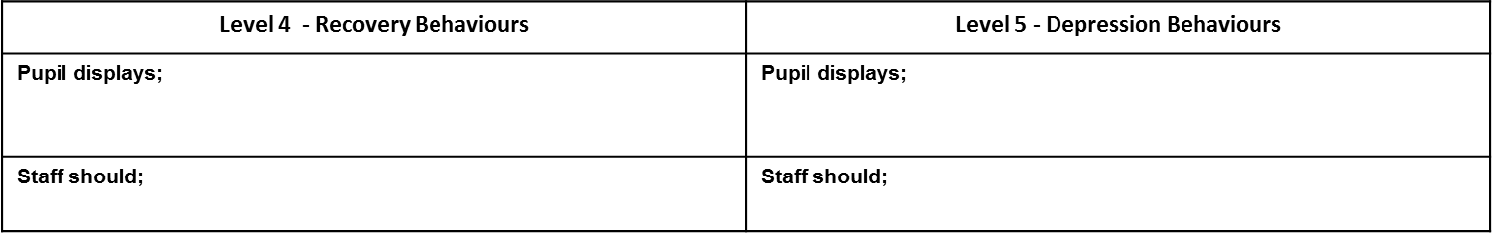
Positive Behaviour Management Plan
Child’s Name:
Date of Plan:
Review Date of Plan:________________________
Child’s Stages of Behaviour

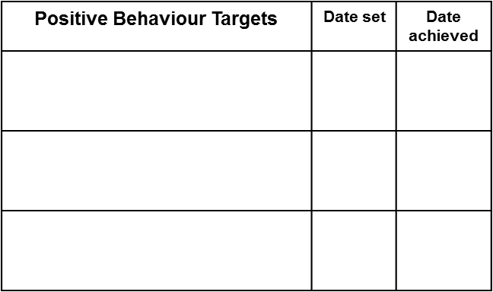
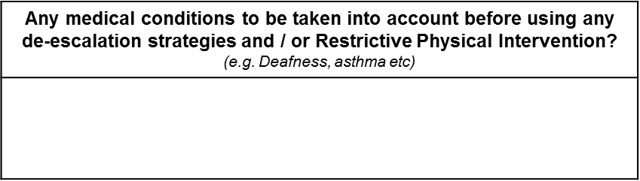
On signing this document you are agreeing to the procedures and strategies being used to address your son/daughters behaviours.
Signing: __________________________ Date: ______________
(parent / guardian)
Signing: __________________________ Date: ______________
(on behalf of the school)

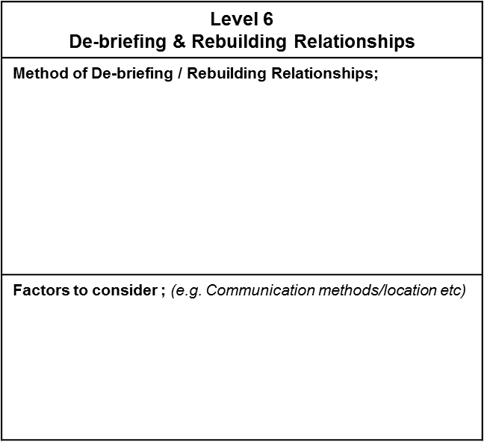
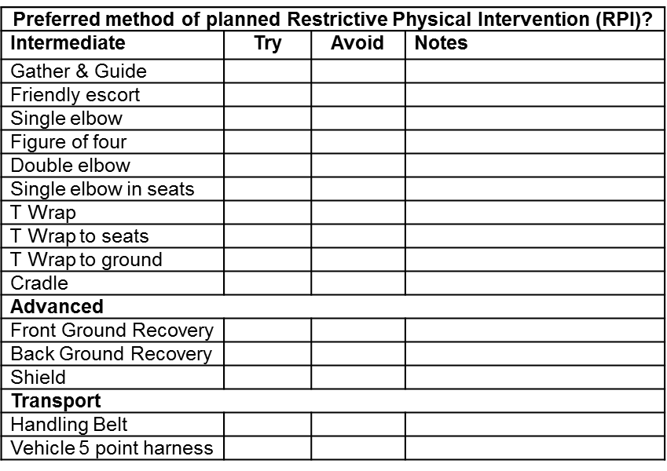
On signing this document you are agreeing to the procedures and strategies being used to address your son/daughters behaviours.

Signing: __________________________ Date: ______________
(parent / guardian)

Signing: __________________________ Date: ______________
(on behalf of the school)

APPENDIX 2

Examples of De-briefing Cards
Comic strip!
Pupil:______________________________
Staff:_____________________________
Date:______________________________
Me
This happened....
I felt....
If I feel like this again I will....
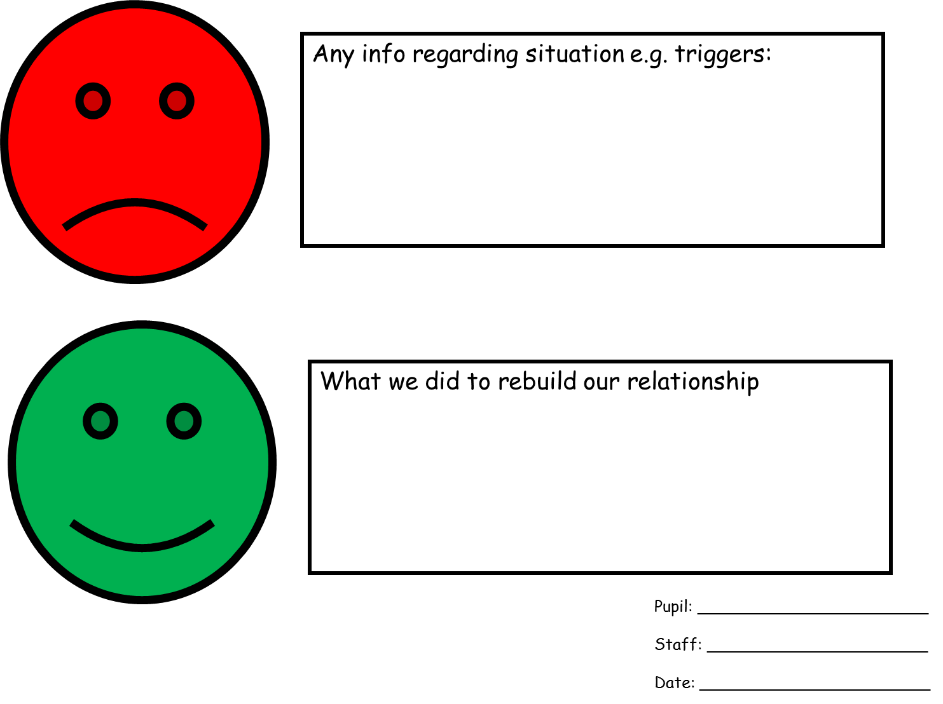

APPENDIX 3

Examples of De-escalation and Diversion Strategies used at Foxfield School

Examples of de-escalation and diversion strategies
De-escalation strategies at Foxfield School may include;
- Change of environment (pupils may ‘go on a job’)
- Change of face (a different/new member of staff deals with the situation but remains in line with the pupil’s Behaviour Management Plan)
- Change in tone of voice
- Change in body language, calm stance and posture
- Humour
- Model desired behaviour
- Build in routines
- Doing something unusual
- Give freedom
- Remind of consequences
- Remind of rules and responsibilities
- Give empathy (not patronise)
- Engineer success / praise
- Change noise / light / scent levels
- Change activity
- Remove the audience
- Use private, understood signals
- Use powerful pauses / silence
- Take up time
- Use help scripts
- Photos / happy book/ Toys / Objects
- Count down or up (use timers if needed)
- Communicating with pupil using careful use of language
- Physical support (being held in this instance is not RPI)
- Sensory Diet (see Michelle)
- Intensive interaction
- Massage (refer to Aromatherapy and Massage Policy)
- Mirrors
- Drink / food
- Medication
- Body position of pupil
- Make a deal cards/Working for cards/ waiting for cards

APPENDIX 4

Sleuth Guidance

Form completion
Check list

The information you place on these incident form(s) will be used in a Court of Law if a complaint is made or an incident goes wrong.

Please ensure you have included all the following information;

- Make sure the time of the incident is correct.

- Make sure all boxes have the relevant information highlighted
E.g. Location, seating, interaction etc.

- You have two opportunities to comment on the incident. You need to include;
- Total duration of the incident
- A description of the build up
  - Some idea of the trigger (if known)
  - Some of the behaviours highlighted and what staff did
what in response

- Action / Actions taken (you can add more than one action)
  - If RPI is used all holds need to be recorded.
  - All antecedents including if the calm room was used.

- Checklist (e.g.)
  - Accident forms that have been signed by Paul
  - If a listening and learning activity took place.

You have a second opportunity to comment, here include;
    - Who used what technique (if more than one)
    - What side each member of staff held the pupil (who did what)
    - If any injuries occurred, who and to where
    - Which calm room / area was used.
    - What the Listening and Learning (debrief) looked like.

Any problems please complete and save what you can and seek support from; Thom, Becky, Steve, Sarah or Ann-Marie

