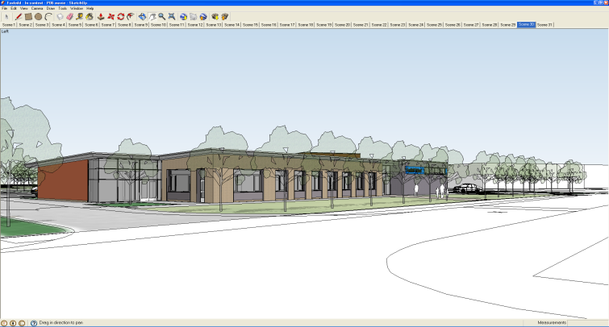
ILS Curriculum Policy Document 2018

Introduction
Foxfield School is a secondary school based on the Wirral. It caters for pupils with a range of Complex learning difficulties (CLD), from severe learning difficulties (SLD), profound and multiple learning difficulties (PMLD) and pupils on the autistic spectrum (ASD). In addition, a number of our pupils have associated needs such as Sensory and Physical impairment, challenging behaviours and English as an additional language.
As a school we recognise that the diversity of the pupils and their learning styles require teaching approaches which reflect their needs through specialised, modifies and structured teaching methods.
At Foxfield, great emphasis is placed on developing the skills required to lead as independent a life as possible and this is reflected within the timetable.
Aims
To deliver a curriculum that facilitates independence through the development of personal care and daily living skills.
To enable pupils to lead a full and active role within the community.
To promote safety both in the home and community settings.
To allow pupils to communicate with others effectively, and to make choice about their day to day lives.

Goals
To develop good personal and food hygiene practices.
To develop the skills necessary to enable independent dressing, toileting and eating/ drinking.
To develop the skills necessary for travelling, shopping and using other community facilities
To realise and enforce good safety procedures
To develop the skills necessary for caring for ones home.
To develop the skills necessary for basic food preparation.

Organisation of the curriculum
Independent Living Skills (ILS) is split into three main areas; Personal Care, Community and Daily Living Skills.

Personal Care
- Dressing and undressing skills
- Personal Hygiene
- Toileting
- Personal Style
- Eating and Drinking

Community
- Travel and Road Safety
- Leisure
- Shopping and money

Daily Living skills
- Safety in the home
- Food preparation
- Domestic Skills

Classes will be provided with curriculum documentation (planning sheets). These provide the key skills and suggested activities for each topic and ability group. These should be used alongside and other relevant documentation such as Personal Progress documents.
All classes receive half a day per week dedicated to the teaching of ILS as well as dedicated teaching time at break and lunch times.
KS3
- Extra time during swimming sessions
KS4
- Timetabled ‘Qualification’ sessions may be used to complete and ILS qualifications (PP, PSD)
Post 16
- Timetabled ‘Qualification’ sessions may be used to complete and ILS qualifications (PP, PSD)
- Timetabled ‘Key Skills’ sessions may be used to cover areas of the ILS curriculum.

Health and Safety
Each teacher is issued with a health and safety booklet containing risk assessments based on Health and Safety advice provided by the L.A. as well as following guidelines set out in the Foxfield Health and Safety Policy.
All teaching staff and TA3’s hold a level 2 certificate in Food safety in Catering.

Links to other areas;
ICT
‘Out and About’ (1 and 2) is a popular and useful teaching program that is freely accessible via the school intranet.
Easy meals resources and books
Simple meals- teaching program with associated reading books that may be found in the school library.
There are also a number of interactive smart board activities and iPAD apps suitable for use during ILS sessions.

Literacy
Simple meals books available in the library which have associated ICT resources
Numeracy
Money, time, measure
Assessment and Recording

Staff teaching the ILS will make both observational and formal assessments of pupil performance in all three areas. Observational records will be kept by teaching assistants and teachers and noted on the relevant recording sheet to inform future planning. Formal records will be kept using ILS levels. Evidence of attained ILS levels in each of the subject areas will be produced twice yearly and kept in the individual pupils’ Progress Files. Evidence may be written, diagrammatic, photographic or a witness statement. An electronic record for ILS levels will be held on the school’s intranet and will be updated twice yearly (February and July) by all staff who are responsible for the delivery

PMLD
Those teachers responsible for the delivery of ILS to PMLD classes will differentiate the curriculum to a level appropriate for those pupils. Assessment within the PMLD classes will also be assessed via ‘Routes for Learning’.

Resources
Resources for the delivery of the Daily Living Skills curriculum are located in the Food technology room. This room consists of 4 cookery bays each containing an oven, sink, cupboards, toaster, kettle, microwave and full set of utensils. There is also a main teaching area consisting of tables, chairs and whiteboard. Other larger items e.g. food processors etc can be found within the food tech store cupboard.
Pupils all have Mersey travel Passes to enable them to access buses and trains during their independent travel training. Staff are issued with daily ‘Saveaways’ to enable them to accompany their groups. The school’s two minibuses (both Wheelchair accessible) are available for use when public transport is impractical.

Various other resource boxes are available to loan from the ILS co-ordinator these include;
- Personal care
- Cleaning the home and safety in the home
- Independent travel
- Money skills
All pupils are offered and encouraged to participate in a week long residential course at suitable outdoor pursuits centres. These residential courses are offered every year. See Residential policy doc.

Staffing
Ind/Home has the support of a Teaching Assistant (level 3) based in the ILS unit (part-time).
Independent travel has a dedicated Teaching assistant who work with pupils on a 1:1 basis

