Foxfield School
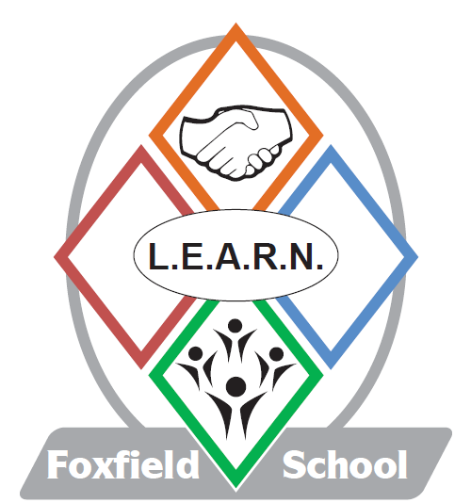


Volunteers Helpers in School 2018

Introduction

At Foxfield we welcome the help and support of a wide variety of volunteers, who give up their time to work with the pupils. These helpers come from a wide variety of backgrounds including:

- Parents of past or present pupils

- Relatives of present members of staff

- Ex or retired members of staff

- “Friends of the school”

- Students wanting experience and placements in order to acquire qualifications

All of our volunteers make a considerable and valued contribution to the life of the school. The opportunities that we are able to offer our pupils, as a part of the main curriculum, and the extra curricular activities that we provide are on occasions dependant upon the voluntary support that we receive.

As a school our prime responsibility is our duty of care to the pupils, and we must do all that we can to protect them from harm. It is therefore crucial that while we welcome volunteers into the school, we are as equally vigilant in our selection and vetting procedures, as we are with our school staff. We have a responsibility to our pupils and their parents, to ensure that those people who come into school and have contact with our pupils, do so for the best reasons.

In accordance with Local Authority guidelines we have set procedures that all volunteers will be required to follow. This enables us to be more aware of the suitability of potential volunteer helpers, and to assess what they have to offer our school.

This document mentions a range of documents that prospective volunteers are required to read. There are also a number of forms that must be completed and returned to the Head teacher before any volunteer placement can begin. Should anyone wish to discuss any of these documents, or the help that they can offer to the school with the Head teacher or Deputy Head teacher, then they are welcome to make an appointment to do so. We are also more than willing to provide any support that people may need in completing the forms.

While this selection process is designed to minimise the risk of a potential abuser working as a volunteer with our pupils, we appreciate that it can be a little off putting. Rest assured that we do not view offers of help with suspicion, but we do need to assess the suitability of people who may come into contact with the pupils at Foxfield.

N. B.
It is therefore important that volunteers do follow these procedures as failure to do so will mean that we cannot accept your offer of help.

The role of the volunteer

In school volunteers will be assigned to a particular group of pupils, or a specified activity. They will work under a member of staff who will have overall responsibility for the pupils and activity at all times.

The duties of the helper will be discussed and agreed by the class teacher and the volunteer. All decisions concerning the activity, and pupils’ behaviour, and the involvement of the volunteer remain strictly with the jurisdiction of the teacher, who is ultimately responsible at all times.
The teacher will give the volunteer the necessary support and guidance, and the volunteer will be encouraged to review and evaluate their contribution at regular intervals.

The school has very detailed policies concerning a wide variety of areas including Supervision, Health and
Safety, and Behaviour management. It would be inappropriate to expect volunteers to read and remember every document, but everyone in school should be aware of basic procedures for Health and Safety, Child protection and Behaviour Management. Volunteers should discuss these with the class teacher or Head teacher, and feel free to ask questions.

When appropriate volunteers will be encouraged to take normal breaks in the staff room.

Volunteers should not get involved with any Team Teach physical restraint as all Foxfield staff have had specialist training in this field.
Additionally they should not be involved in changing students or in any personal hygiene activities.

All volunteers should make themselves aware of the appropriate targets for the pupils with whom they are working, including any behaviour management strategies. The class teacher should explain these to the volunteer and how they can play a part in helping pupils to achieve them.

Volunteers must accept the confidential nature of their involvement in school, and respect the right of privacy of all pupils and staff.

Guidelines for Volunteers

The staff Code of Conduct

This document applies to those whose work brings them in contact with young people and needs to be read. It is the same for volunteers as it is for employees.

Private meetings with pupils

Volunteers should be aware of the dangers which may arise from private conversations or of being alone with individual pupils. Direct contact with pupils away from the school premises are not permitted unless specific approval of the Head teacher has been obtained.

Caring for pupils in specific situations

Volunteers should never administer first aid as this should be carried out by the dedicated first aider or school nurse. Additionally medication should never be administered by a volunteer.

Likewise volunteers should not get involved in the personal care of pupils or with their toileting needs.

Where advice may be acceptable

Volunteers in schools may from time to time be approached by pupils for advice. Pupils may also appear distressed and volunteers may feel the need to ask if all is well. In such cases volunteers must judge whether it is appropriate for them to offer counselling and advice or whether to refer the pupil to another employee with acknowledged pastoral responsibility for the particular pupil. If a child makes an allegation or disclosure to a volunteer they must not discuss this with anyone but need to report it straight away to the safeguarding officer (Head Teacher) or if not available to the Deputy Safeguarding officer (Deputy Head Teacher)

Volunteers general relationships and attitudes

Volunteers should ensure that their relationships with pupils are appropriate, taking care that their conduct does not give rise to comment or speculation. Attitudes, demeanour and language all require care and thought, particularly when volunteers of either sex are dealing with adolescent boys and girls. It is important to keep a professional attitude and act as an authority figure (in the same way as an employee does) rather than in a friendly way which could be misconstrued by pupils and staff alike.

Disclosure and Barring Service Checks

All adult volunteers must have a Disclosure and Barring Service check before they work in this school.

Confidentiality

All adult volunteers must sign a confidentiality agreement before they work in this school.

Signed: ______________________
(Volunteer Helper)

Date: ________________

Signed: _______________________
(Head teacher)

Date: ________________

Please sign one copy of this document and return it to the Head teacher

Form for volunteers working within school or accompanying an educational visit out of school

Full name:

______________________________

Maiden or former name:

______________________________

Home address:

______________________________

Tel. No:

______________________________

How long have you lived at the above address?

______________________________

If less than twelve months, give previous address:

______________________________

How long did you live there?

______________________________

Do you have or have had, children at Foxfield School? Please give their names, ages and the year they started at this school.

______________________________
Please give details of any experience of looking after or working with children.

___________________________

Please give details of any relevant qualifications or appropriate training.

___________________________

Often volunteers have knowledge or skills which may be an advantage to our pupils to share. Would you please tell us about your current or previous occupation, and your hobbies and interests?

___________________________

___________________________

___________________________
___________________________

References
Please give us the name, address and telephone number of two people who know you well. One could be a present or past employer, and the other a professional person who has known you for over two years.

a. ___________________________

___________________________

___________________________
___________________________

b.

___________________________

___________________________

___________________________
___________________________

Have you any previous convictions? YES / NO

If yes give details below:

___________________________

___________________________

___________________________
___________________________

All information will be treated in confidence and used only in consideration of this application.

Please also complete the Police clearance form.

All statements are true to the best of my knowledge.

Signed: ___________________________

Date: ______________________

Please make sure you study the following documentation by referring to this information on our Web site before starting your volunteer service at Foxfield School:

- Code of Conduct
- Dress Code
- Child Protection and Safeguarding Policy
- Health and Safety Policy
- Fire Safety Policy

Thanks you for your cooperation.

I hereby declare that I have read the above documentation

Signed:

___________________________

Date:

___________________________

