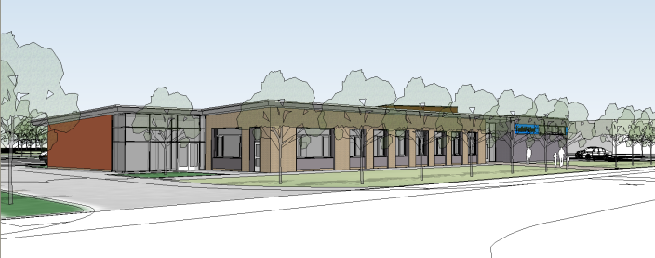
Transition Policy for Multi – Sensory Learning
2020
Multisensory Learning provides specialist provision for pupils with Profound and Multiple Learning Difficulties (PMLD) and non verbal pupils with complex communication difficulties. The purpose of this document is to detail the procedures school will undertake to support a successful transition for new pupils and staff entering the Multisensory Learning classes and for those pupils transferring from class to class within the provision.
Transition is a challenging and anxious time for all involved, particularly for pupils with associated complex health, mobility and sensory difficulties. We as a school recognise that an enhanced transition is necessary to fully prepare pupils, parents and staff for new classes. All our pupils are idiosyncratic in their communication which cannot be easily understood through written accounts. Pupils’ transferring into Multisensory Learning or between classes benefit from school staff observing and working alongside pupils with their current staff. This approach enables unfamiliar staff to become attuned to the pupil’s communication in order to understand when they need health / medical intervention and to gain familiarity with the personalised strategies currently used to support the pupil in all aspects

of school life. A shadowing period is also beneficial for the pupil as they can begin to build a rapport with new staff.
The Role of the Key worker
We recognise the importance of relationships in Multisensory Learning and therefore operate a key worker system. The role of the key worker is to support their pupil in lessons, support their personal care and health needs and act as an advocate for their pupil. Assignment of key workers is done in consultation with staff and in an open, honest and constructive manner. Key workers are usually reviewed after two years so that pupils are able to transfer and generalise their skills with other adults and to reduce dependency on certain staff.
Pupils currently placed in Multisensory Learning who are changing between classes and / or staff will be shadowed by their new key worker for a period of 3 weeks leading up to the end of the summer term. For year 7 pupils (or those transitioning into the school), the assignment of key workers will take place after two weeks of pupils starting school. Parents will be informed and invited into school to meet key workers and the class staff.
Pupil / Parents needs and supporting procedures
Transition meetings with feeder schools take place in the late spring / early summer term and are undertaken by the Head of key stage 3. Information gathering from parents, feeder school staff and health staff is disseminated to class teachers and staff. Additional meetings may take place for those with significant health care needs or subsequent visits to the feeder school may be arranged for further observation and information gathering if necessary. Pupils transferring from year 6 will make three visits to the school (two morning visits and one whole day visit). Pupils attend with staff from their school. During the visits class staff will continue to gather information and observe pupils, i.e. for changing routines, feeding routines. Key information gathered:

- How a pupil communicates
- Communication and cognitive skills
- Mobility
- Vision / hearing and sensory preferences
- Positioning
- Feeding routines
- Changing routines
- Family information
- Health / medical needs
- Physical needs
If parents have particular requests, or need further information regarding transition, they are able to meet with the Head teacher and class teachers to discuss their queries and concerns. School staff will endeavour to assist parents and support them with any further requests or information they require during this time.
Staff needs and supporting procedures
It is essential that staff (new and current) have time to meet prior to the start of the academic year so that information can be successfully disseminated and decisions can be made regarding assignment / reassignment of key workers. Staff will require a minimum of one staff meeting for an information sharing session to take place.
Staff transitioning into Multisensory Learning will need to develop skills so they can carry out their role effectively. Staff will need to undertake a range of training so they can meet the pupils’ educational, health and care needs.
Immediate Training

- Gastro feeding
- Manual Handling
- Routes for Learning
- Other deemed necessary by health professionals for individual pupils.

Long term training

- Oxygen training
- Visual stimulation
- Auditory training
- Resonance Boards
- Objects of Reference
- Body Signing
- Rebound Therapy
- Life guard training

