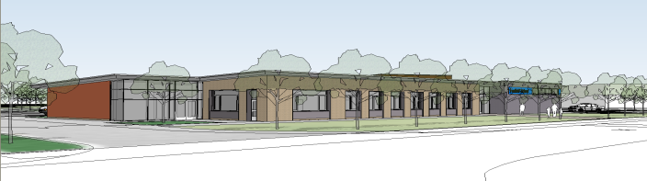
l
Foxfield School
Building Security Check

BUILDING INTERIOR, EXTERIOR AND PLAY AREAS | YES | NO | WHAT IS THE RISK PRESENTED | ACTION TAKEN
Building grounds are fenced.
Restricted areas are clearly marked
All poisonous shrubs, trees, and foliage have been removed.
Bus loading and drop-off zones are clearly defined.
There is adequate lighting around the building.
The building ground is free from rubbish or debris.
Play areas are fenced.
All areas are accessible to emergency vehicles.
No broken window panes,
Window locks are in working order
High-risk areas are protected by high security locks and an alarm system
There is a central alarm system in the building
Multiple entries to the building are controlled and supervised
Visitors are issued I.D. cards or badges
Doors accessing internal courtyards are securely locked from the inside
Exit signs are clearly visible and pointing in the correct direction.
Switches and controls are properly located and protected.
Access to electrical panels is restricted.
There is a method of communicate during emergencies
A visitor policy is in effect, requiring a sign-in procedure for all visitors,
Fire exits are not blocked
Entrance and exit doors are secured to restrict access and egress
Fire exits are fitted with alarms
Fire exits have restricted operation in non – emergency situations
The fire assembly point is clearly identified
All hazardous items are securely locked away
Access and exit from the site is restricted
A map of the locality and neighbourhood is available

