General Internal Moderation Principles

- It is essential that assessment decisions are in line with the qualification standards. The internal and external moderation process is in place to ensure that all assessments are applied consistently for all candidates and that the final judgement is accurate, reliable and recorded.

- Internal moderation should be on-going throughout the course, with feedback being given to the assessors. There should be evidence of feedback being actioned where necessary.

Beth Coughlin | Jess Fogg
Lydia Gorton | Dassa Roche
Jill McTearny | Rachael Aindow
Rachel Smyton | Nicola Daniels
Becky McBride | Natasha Hargreaves
Denise Karythis | Steve Ledson
Emma Wall | Ian Harwood
Rebekah Cuthill | Denise Karythis
Ritu Hulme
Steph Haslam
Paul Howley
Tara Bennett
Gavin Attwood
- Summative internal moderation must be carried out prior to candidates being entered for external moderation. Only those assessors whose candidates have fully met the standards can be entered for external moderation. Entering those who have not met the standards will jeopardise the success of those who have met the standards. If a tutor is found to be entering candidates for moderation who have not met the standards, disciplinary procedures may be implemented.

- It is the responsibility of all staff to

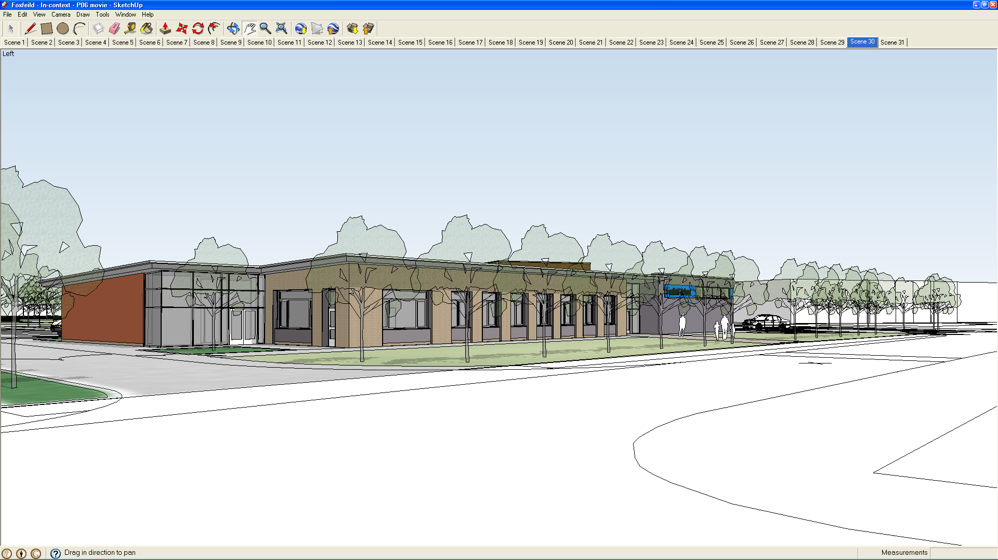
Foxfield School Internal Moderation Process - 2020

- participate in the moderation process by keeping the necessary records, attending relevant meetings and submitting marked student work as requested.

- All assessment evidence, which has been internally moderated, must be kept onsite until after the external moderation. The work remains the property of the candidate and can be returned to the candidate according to the requirements of the relevant awarding body.

- This policy is reviewed annually (date due September 2019)

List of Moderators for PP 2019 to 2020
Internal Moderation Process for Centres
First 6 weeks of term
- Establish numbers of student cohort

- Establish levels that these candidates will work on

- Register candidates (CANa)

- Allocate IM(s) to assessor(s)

- IM to approve proposed SoW / assessments

- IM to draw up sample plan (not to be shared with assessor – see IM process example sample plan)
2nd half of first term
- Co-ordinator to ensure that all IMs and assessors have met

- First round of formative internal moderation to be conducted. One copy of feedback sheet (see page 4) to be given to the assessor, one to be stored centrally in the centre portfolio for auditable purposes

- Meeting held to discuss issues arising from first round of internal moderation. Minutes taken (see page 3)
1st half of second term
- Second round of formative internal moderation to be conducted. Documentation to be copied as before and stored in the centre portfolio
- Any action noted by the IM on first round to be checked and signed off

- Meeting held to discuss issues arising
2nd half of second term
- Third round of internal moderation to be conducted. Documentation to be copied as before and stored in centre portfolio
- Any continuing issues to be addressed and signed off

- Meeting held to discuss issues and plan for external moderation
1st half of 3rd term
- Co-ordinator to establish candidates and units to be put forward for external moderation

- Summative internal moderation to be conducted

- Arrangements to be made for External Moderation

2nd half of third term
- External Moderation takes place

- Meeting to be arranged to discuss feedback from External Moderation and plan put in place to address any issues arising
Back to Term 1 again

Minutes from Internal Moderation Meetings

Persons present: | Date:

Issues arising: | Action agreed / person(s)
 | responsible

Date agreed for next meeting:

Feedback to Assessor Sheet for Formative Internal Moderation

Candidate name: |  | Date:
Assessor name:
Internal Moderator name:
Qualification title:
Unit(s) moderated:
Comments / feedback on how assessment / evidence meets the standards:

Comments / feedback on completion of mandatory paperwork:

Assessor signature: |  |  | Date:
Internal Moderator signature: |  |  | Date:
Date agreed for any action identified to be completed by:
Internal Moderator signature |  |  | Date:
to confirm action completed:

