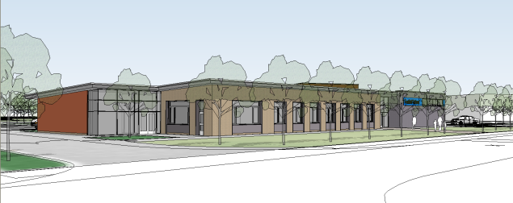

Rationale

Off-site visits/activities are arranged by or on behalf of the school, and would normally take place outside the school grounds. The governors and teaching staff believe that off-site activities supplement and enrich the curriculum of the school by providing experiences that would otherwise be impossible. All off-site activities must serve an educational purpose, enhancing and enriching the pupils learning experiences.

In this policy, Foxfield School seeks to establish a clear and coherent structure for the planning and evaluation of our off-site visits in order to manage and minimise risk, ensuring the health and safety of pupils at all times. We seek to make our visits available to all pupils whatever their ability or challenge. The visits usually take place within the school week although on occasions some groups of pupils e.g. Duke of Edinburgh scheme pupils may take part in a residential experience at the weekends.

Aims and Objectives

The aims of our off-site visits are to:
- Enhance curricular and recreational opportunities for our pupils;
- Provide a wider range of experiences for our pupils than could be provided on
- the school site alone;
- Promote the independence of our children as learners, and enable them to grow and develop in new learning environments
- To give pupils more experience of working together, collaborating and
Educational Visits Policy
2018

- cooperating.
- Develop self esteem

Educational Visits and the Equality Act 2010
School trips, including field trips and residential trips are an important part of school life. We seek to ensure that any trips that we arrange do not discriminate against any of our pupils. However, in a few cases it may be impossible to make a school trip accessible for a pupil on health and safety grounds due to severe health concerns or extreme challenging behaviours demonstrated by the pupil.
Forward planning assists us in arranging trips in which all pupils are able to participate. Therefore if the assessment identifies that the risk is too high to take part in a category C residential pupils will be given the opportunities to take part in category A or B visits, or where possible, to visit the residential (category C) placement as a daytime visitor.
The risk assessments that we carry out in relation to school trips includes a consideration of the reasonable adjustment needs of Foxfield pupils.

How visits are authorised

Staff proposing to arrange an off-site activity must seek to obtain the approval of the Headteacher or Deputies in advance, before any commitment is made from the school. These trips are usually in the community for half a day or a day, usually classed as category A visits. Residential trips however, are generally organised by the Educational Visits Coordinators (Deputies) and are classed as category B or C visits.

Categories of visits explained

Category A Activities
Activities presenting no specific danger. These activities need to be supervised by a competent member of staff but that staff member does not require a National Governing Body award to carry out such an activity. This sort of Category A activities would include;
- Walking in the local parks
- Walking on non – remote pathways
- Field Studies in environments presenting no technical hazard
- Visiting a café in the community
- A visit to the local shops
- An all day visit to the museum
Category B Activities
This category has slightly higher risk activities which require safe supervision and the leader to have undertaken at minimum a familiarisation process. Therefore the leader will be approved as officially competent to lead the activity by the Local Authority. A National Governing Body award NGB such as Walking Group Leader (WGL) or Basic Expedition Leader (BEL) would be the sort of qualification needed for certain activities in this category. Examples would include;
- Walking in non – remote country
- Cycling on roads or non – remote off – road terrain
- Low level initiative challenges.
Category C Activities
This is the most demanding category and would be in the scope of Adventure Activities Licensing Regulations 2004. A leader would need a variety of NGB qualification. Activities in category C would include;
- High rope exercises
- Sub aqua activities
- Canoeing
- Climbing
- Gorge Walking etc.

Planning a Visit

For any external visit a Visit Leader must be appointed (this is normally the class teacher). This person will ensure that the School Trip proforma and the Off Site Educational Visit
Planners are completed. The Assessment of Potential Hazard sheet should be completed. The generic Wirral ‘Risk Assessment Sheet for Educational Visits and Off Site Activities’ should be consulted for guidance on managing the following risks:

- Transport
- Parking the bus
- Footpaths and pavements
- Weather
- Lost Party Member
- Risk of interference by members of the public
- Risk of serious challenging behaviour
- Illness or accident during visit

Where possible a pre-visit by the Visit Leader is recommended and all possible risk assessments completed.

- Curriculum Objectives
The exact aim and educational purpose of the visit should be identified.

- Itinerary
A full break down of the day’s events, to include transport transitions, activities and probable timings should be shared with all the staff attending.

Consideration should also be made for possible occurrences, such as adverse weather conditions, with alternative options being explored.

- Supervision/pupil ratios
The exact staff / pupil ratio needs to be decided depending on the activity and the needs of the group concerned.

All staff and volunteers should be made aware of the aims and objectives of the trip and of their specific roles and responsibilities on the day. A list of those volunteers who are CRB checked is kept in the office. All volunteers whether CRB checked or not should be briefed that they must not have unsupervised access to children.

- Transport
The Educational Visits Coordinator will book a coach or minibus and will ensure that they are reliable operators who comply with all relevant H&S standards.

If using staff vehicles ensure that the insurance covers business use.

For after-school events, parents will transport their own children to and from school or arrange lifts with parents of other children. It is made clear that it is their own responsibility and where possible, their mobile numbers are retained by the visit leader.

- Emergency contact details
The Visit Leader must ensure that they take the school mobile phone with them on any external visit or leave their own mobile phone number with the School Office. They must ensure that the mobile phone has enough charge to last the extent of the visit. All contact details (for both pupils and staff) should be retained in the school office and also by the teacher in charge.

Therefore, a designated ‘contact’ person based at the school should be assigned for the duration of the trip (even when after school hours) to provide contact details when required.

For residential visits the ‘contact’ person should provide after-hours phone numbers. All details of pupils going on the residential should be retained by the Headteacher and taken home at night so that he has these close at hand should an emergency occur.

- First Aid/Medical details
A designated first-aider or emergency first aid trained person should be assigned for every external visit. This person should be aware of any specific medical needs (for both pupils and staff).

- Parental Consent
The parents of pupils taking part in an off- site activity classed as a category B/C visits should be provided with all the appropriate information about the intended visit. Parents must give their permission in writing before a child can be involved in category B or C off-site activities. General permission forms for category A visits are sent out and signed by parents’ of year 7 pupils entering the school in September at the beginning of the academic year.

During the Visit

The Off Site Educational Visit Planner (Groups

out of school form) should be left with the contact person at the school or in the case of a category A day visit, with the school secretary in the office.

In the event of an emergency the school should be contacted immediately and the contact person will follow the procedure as outlined in the Emergency Plan.

After the Visit (Category B/C visits only)

The visit leader will review the success of the visit with the Educational Visit Coordinators (Deputies) and an evaluation should be completed to aid future visits.

Visit Leader Must Do:

Complete the School Trip proforma and the offsite educational visit planner – visit proposal (Groups out of school form) and share with Headteacher or Deputies.

Complete assessment of potential hazards and share control measures with visit supervisors
List all staff members / all volunteer helpers are they CRB checked – if not ensure no unsupervised contact.
Check ratio of adults / children – is it ok?

Note date / time of adult / child briefing and ensure all areas covered.

Have fully charged mobile phone – if own – has school office got number?
Emergency contact number to be recorded for the visit - home and away.

The visit must be submitted within the specified time period (Category B/C visits only)

After the visit evaluation should be completed with the residential coordinators.

External Visit Co-ordinator (EVC)

The Head Teacher will ensure that the school has a trained External Visit Co-ordinator who will be involved in the planning and management of all category C visits. (This will normally be one of the two deputies).

The EVC will:

- Ensure that visit planners and risk assessments are completed and, where appropriate, individual safety plans and safe working practices are in place and followed.
- Support the staff to ensure visits are approved.
- Ensure all contact details are obtained and a ‘contact’ person is assigned and aware of emergency procedures.
- Keep records of all off-site category C visits.
- Provide after-visit evaluations in order to improve the quality and safety of future visits

NB
At present the Deputy for Staffing and Resources is the EVC1 with the Deputy for pupils and curriculum being the EVC2.

The School visits pack at Foxfield School

Every year once a residential has been planned a number of forms are issued to class teachers in order for them to ‘fine tune’ the planning for their particular class residential. This includes letters to parents explaining where and when the residential is, the types of activities likely to be undertaken and any other necessary and important information. This is also accompanied by a parental consent form which must be returned in order for the pupil to take part in the visit. Nearer the date of departure a kit list will be sent home reminding parents to take account of all weather eventualities.
At the same time the EVC’s will enter information into the Evolve software (see below) which informs the authority of the school intention to take part in the visit and ultimately asks the authority for permission to do so.
Medical kits
All groups going out of school on the minibuses should be aware that both minibuses have medical kits on board. For groups going out in the community it is not necessary to take medical kits as quick contact can always be made with school if need be. However, for all full residential visits medical kits should be taken as part of the ‘day bag’, (see below), even though the centres themselves will have adequate medical facilities.

First Aid
Most staff at Foxfield have a regular 3 yearly update in one day emergency first aid training. Other staff involved in areas such as Duke of Edinburgh, Pool Safety and Team Teach Leaders are required to have a 4 day first aid qualification which is renewed every 3 years with refreshers courses held on a regular basis. Therefore when any group goes out of school on an educational visit there will be a member of staff qualified in Emergency First Aid as a minimum.
Day bags
Day bags are taken out on each day of the visit there is also a Residential bag which goes with groups to each centre. These bags are stocked with essential items to be used when pupils have not provided their own. These include; wipes, latex gloves, toothpaste, spare tooth brushes, combs, shampoo and conditioners, hand gel, yellow waste bags, bin bags, deodorant, shower gel, disposable razors, shaving foam, first aid box, sanitary towels, sun block, after sun, door alarm, sewing kit etc.
Personal belongings
The school is not responsible for lost or mixed up clothing so to prevent items of clothing getting lost all parents should have iron on name tags in their child’s clothing.
Form 6
Form 6 (now the Evolve software) is completed by the EVC’s on line, for instructions see appendix 1 below.

Centre group leaders
Centre group leaders will have a variety of qualifications in outdoor pursuit’s activities. However, ultimately when on an outdoor pursuit’s site the ultimate responsibility for the group continues to remain with the class group leader. It is the member of staff from the school who will take responsibility, risk assess, discuss with the outdoor pursuit leaders on safe practice for various activities and ultimately have the final say in who takes part in activities or what activities are or are not suitable for their group and individual pupils.
Day visits
When pupils go out on day visits parents are notified but parental permission is not required as this is often part of the schools normal curriculum time i.e. for Independent Living Skills work. In these cases it is suffice to fill in a ‘Groups out Of School’ form which contains pupil’s names addresses and phone numbers with an emergency mobile contact number. Additionally on the form are details of staff accompanying the group a mobile phone number they can be reached on and details of pupil care plans and risk assessments taken into account before leaving the premises.
Pre – visits by staff
Prior to the group going on a category C visit the group leader will be given up to one full day to go to the centre to meet group leaders, decide on the itinerary, discuss health and safety issues and to carry out a risk assessment of the site. Note that this assessment is a separate Foxfield

assessment and is in addition to the risk assessment that the centre itself has developed. The group leader is given this time specifically to plan and prepare for the groups visit and therefore the assessment will be specific to factors relating to that particular class group and the individuals within it. This assessment will be carried out each time a leader takes a group to the centre and so it does not matter how many times a leader has visited the site, there will always be a new assessment made for a group of individuals.
Risk assessments
Foxfield School has close to two hundred risk assessments for various circumstance and instances. Training has been given to all staff into how to write a risk assessment and the type of issues that need to be taken into account when developing one. New assessments are being made all the time especially as a large percentage of the curriculum can take place within the community.
NB
For further information about individual activities and courses please refer to Wirral LEA Educational Visits Policy
PDH 2012 – updated 2015

Monitoring and Review

This policy is monitored by the appropriate Committee of the Governing Body and will be reviewed every two years.

Appendix 1
Information about the centres
The Wingate Centre
The Wingate Special Children's Trust,
Wrenbury Hall Drive,
Wrenbury,
Nantwich,
Cheshire UK CW5 8ES

Telephone / Fax: (01270) 780456
International (+44) 1270 780456

e-mail : gym@wingate-sga.org.uk
‘The Wingate Centre is the largest holiday centre for disabled children in the UK, providing life – enriching holidays for up to 1400 children and young people with special needs each year.’
The Wingate Centre is a charitable organisation based in Cheshire. They have a large gymnasium with floor level trampolines and soft play area. The centre provides breakfast, packed lunch and an evening meal each day. Groups visiting the Wingate Centre usually have one or two sessions in the gym then use the centre as a base for local visits.
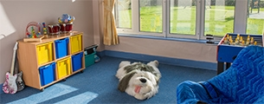

With our fully accessible accommodation and facilities in a private and peaceful location, experienced staff and a variety of on-site activities to choose from, children will leave the Wingate Centre with lots of positive experiences and new skills.
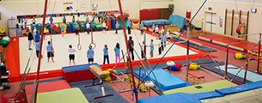
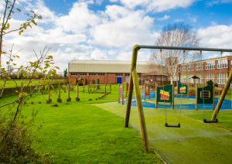
The Play Dale Adventure Playground has scramble nets, log climbs and a traversing wall
The Calvert Trust

The Calvert Trust
Little Crosthwaite
Keswick
Cumbria
CA12 4QD
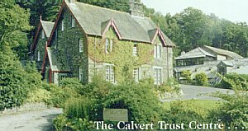
Calvert Trust
Telephone/Minicom: 017687 72255
Fax: 017687 71920
E-mail: enquiries.calvert.keswick@dial.pipex.com
Calvert Trust
The Calvert Trust Centre offers rock climbing, abseiling, canoeing, sailing, Zip Wire, Horse riding, Pony and Trap Driving, Hill Walking, Ghyll Scrambling, Archery, Orienteering Mine Visits and other Activities are organised and staffed by the centre.
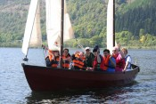
MAP:

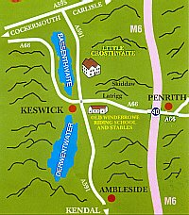

All-inclusive and hassle free...

Everything is included; all you have to do is get here!

- Enjoy fantastic home cooked food for the duration of your stay, special dietary requirements are no problem.
- Accommodation is comfortable and accessible, every room has an ensuite wetroom.
- All of our activities are also accessible; we use specialist, adapted equipment and expert, experienced staff to make the most of the natural beauty of the Lake District National Park. Our custom buit, on site facilites offer a range of nearby and wet weather activities.
- Dont forget to check out our state-of-the-art water centre, a sensory hydrotherapy pool with music, lighting, bubbles, and a sauna.
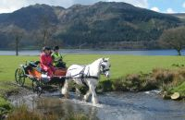
Wirral Community Narrowboat Trust Limited
The Wirral Narrowboat Trust operates from the Ellesmere Boat Museum. Trips are usually on the Shropshire Union Canal but could be anywhere in the northwest. The vessel accommodates ten plus two volunteer crewmembers. There is a small galley for cooking plus many canal side pubs and restaurants. Wheelchair access is good employing ramps and a lift but can become a little cramped inside.
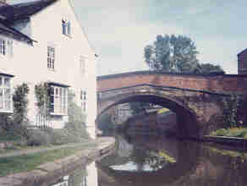
OUR NARROWBOATS have been built to our specific requirements to provide amenities suitable for the needs of disabled users. Each boat carries a maximum of 12 passengers and is crewed by trained and D.B.S accredited W.C.N.T. volunteers.
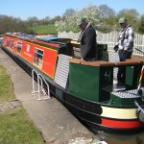
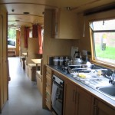

Suitable for Day use and for Residential cruises with sleeping accommodation for up to six adults in addition to WCNT crew. Hoist for disabled transfer from or to wheelchair
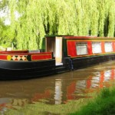

Wirral Community Narrowboat Trust
c/o Hillyer McKeown
1 Hamilton Square
Birkenhead, Wirral
CH41 6AU
Tel: 0151 357 1783

Kingswood Outdoor Centre, Loggerheads, North Wales
Top of Form
Bottom of Form
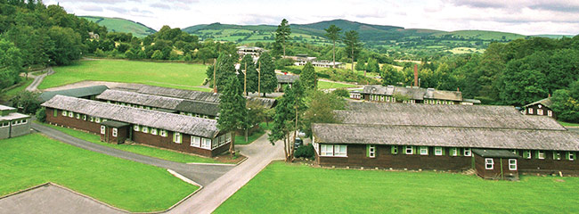
Colomendy Activity Centre

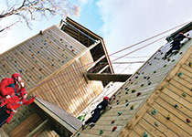
- Outdoors: Activities integrated into the stunning woodland, including three huge climbing and abseiling towers, high and low rope activities, a 3G swing, a 200 metre giant zipwire, and an exceptionally realistic caving system built into a natural rock seam
- Indoors: Spacious sports hall for team games, fencing and recreational activities
- Watersports: Purpose built watersports lake for raft building, kayaking and canoeing
- Other facilities: Diner, shop, chill out areas, party leader lounges and classroom spaces
- Security: the centre site is fully secure with boundary fencing, security gates and CCTV

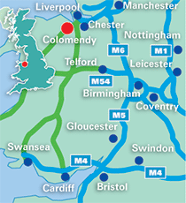
Colomendy Centre for Outdoor Education, Loggerheads, Near Mold, Denbighshire, CH7 5LB
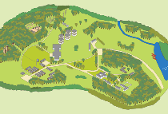

Colomendy Activity Centre
With fond memories through its history, Colomendy has become woven into the life of over 350,000 children who have visited the Centre over the years and enjoyed that unique “Colomendy experience”. Often referred to as the “Gateway to North Wales”, Colomendy is situated in a magnificent setting in the heart of an Area of Outstanding Natural Beauty.

Beautiful Welsh Valley
The 130 acre site is located just off the A55 Expressway, set deep in a beautiful valley designated a Site of Special Scientific Interest. Surrounded by scenic hills and woodlands, it is one of the UK’s finest education & adventure centres. The huge site remains peaceful even when full, with vast open spaces for children, brimming with wildlife like badgers, bats, eagles, newts and woodpeckers.
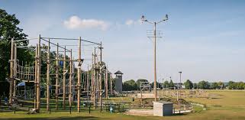
For its opening, Colomendy received a multi-million pound redevelopment that has paved the way to it becoming one of the UK’s premier Educational Activity Centres. This includes a £1 million adventure park with three huge climbing and abseiling towers, high and low rope activities, an adrenaline 3G swing, a monster 200 metre Giant zipwire and a major simulated caving system built into a natural rock seam.
The River Alyn runs through the Northern end of the site, and alongside this we’ve constructed a purpose-built watersports lakes. One of two centres offering watersports sessions, Colomendy boasts canoeing, kayaking and raft building.
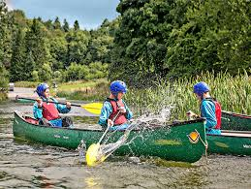
Acommodation for both teachers and students is either in our cabins, or towers, some with en-suite bathroom facilities, with upgrades of existing buildings providing a new reception, restaurant area and Evening Entertainment Zones. The centre site is fully secure with boundary fencing, security gates and CCTV.
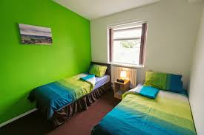
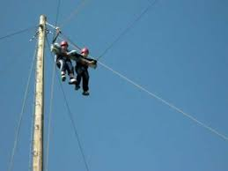
Barnstondale Camp, Barnston, Wirral
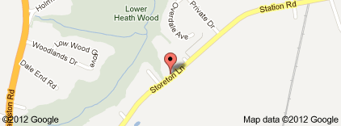
Barnstondale Centre offers affordable, residential and non-residential breaks to groups of young people from the Merseyside areas that are considered disadvantaged in some way i.e. Financially, physically or emotionally. They are set in the heart of the Wirral Peninsula in 15 acres of countryside that includes an ancient woodland dale, stream and pond.
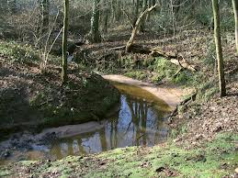The Centre provides first class facilities and an environment which is far removed from everyday inner-city life. There is a structured routine and a varied activity base to assist group leaders in facilitating their self-devised programmes in order to work on improving self-esteem, widening horizons and increasing the motivation of our young communities. The Centre offers completely accessible facilities and excellent accommodation on a full board or self catering basis and can accommodate groups of varying size, up to 150 people via a mix of dormitories, log cabins and en suite rooms.
Facilities include classrooms, meeting rooms, art room, assembly hall, leaders lounges, tuck shop, stage venue, floodlit all weather pitch, outdoor football pitch, adventure playground, a variety of indoor/outdoor sporting facilities, games rooms and the opportunity to experience a wide range of morale building outdoor pursuits including archery, canoeing, orienteering, problem solving, abseiling and rock climbing, both on and off site. The activities offer a challenging and rewarding experience to all participants and are equally effective in building social skills as they are physical ones.

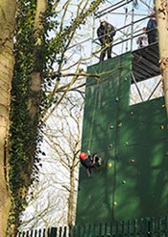
As an Adventure Activity Learning Association licence holder, all activities are professionally supervised by fully qualified staff and full risk assessments are available to view. In addition there is an exciting new abseiling tower which means they can provide outdoor climbing & abseiling experience without leaving the site. The tower is the tallest in Wirral and is professionally supervised to ensure absolute safety. This really is exhilarating and motivational fun at its most extreme and is proving immensely popular with children and leaders alike. Day usage and residential available.

Crosby Lakeside Adventure Centre
The Esplanade Off Caimbridge Road, Seaforth, L22 1RR
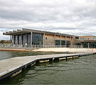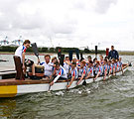
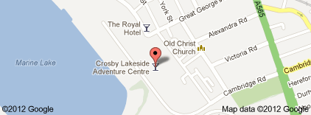
In the heart of Crosby Coastal Park, a 15-minute drive from Liverpool city centre, Crosby Lakeside Adventure Centre offers many water activities, a fitness centre, a bar and a restaurant.
Guests staying at the Adventure Centre have access to activities such as sailing and canoeing, while fitness classes are also offered. Parking is free at the hotel.
With views of the Lake, Lakeside Bistro and Bar serves modern British and European dishes. A carvery is available on Sundays and a full English breakfast is provided every morning.
The bedrooms are modern and all have their own bathroom with a shower. Rooms also feature tea/coffee making facilities.
N.B - Generally used for day visits only

Manor Adventure – Culmington Manor, Craven Arms, Shropshire
This centre is the latest addition to our residential experiences bases for our pupils
Culmington Manor offers exceptional facilities within a 100 acre estate in an area of outstanding natural beauty in the South Shropshire countryside. Our superb estate is located close to the Welsh borders and nine miles from the historical town of Ludlow. The grounds consist of woodlands, fields, and gardens inhabited by an abundance of wildlife. Hidden away in the Corvedale Valley,
There are lots of activities for pupils to try such as High Ropes, Archery, Orienteering, Climbing and Archery to name but a few.
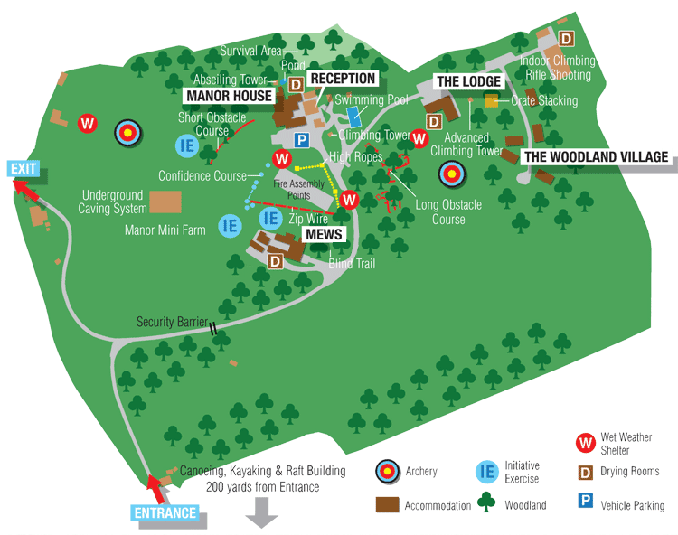
Map of grounds
a safe and secure environment for schools to enjoy outdoor pursuits. The centre operates within a very compact central area with the majority of activities taking place within 15 acres surrounded by the various accommodation options.
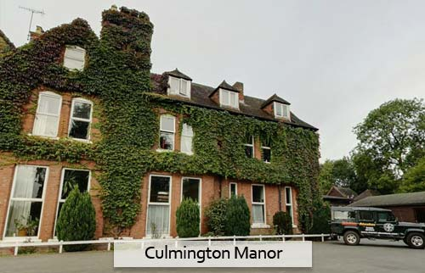
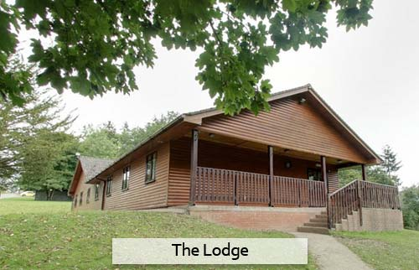

Our Accommodation
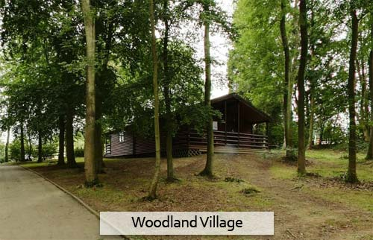
Address: 1 West Lodge, Seifton, Craven Arms SY7 9BY
Hours:
Open today · 9am–5pm
Phone: 01584 861333
Conway Centre
Llanfairpwllgwyngyllgogerychwyrndrobwyll-llantysiliogogogoch - Anglesea

Location
The centre occupies 169 acres of National Trust parkland and gardens which extend down to the Menai Strait. It has easy access to the coastal path.
Only 1 mile away from Llanfairpwll and 4 miles from Bangor.
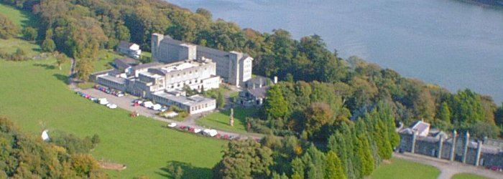
Welcome to Conway Centres: Anglesey, where you can experience high quality arts and outdoor education, which has the potential to raise achievement, whilst broadening participants’ horizons and enhancing aspects of the National Curriculum. Our experienced and qualified teachers can help you organise a progressive programme of residential or day course activities to meet your desired aims and objectives. Whether you are looking for a bespoke programme of activities, or are interested in one of our packages please call us to discover what we can offer.
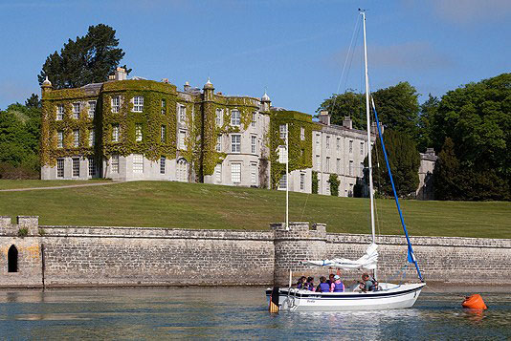
The centre offers a variety of activities such as gorge scrambling, mountain walking, power boating, rock climbing, surfing, high ropes, low ropes, climbing wall, bushcraft, raft building, zip wire, abseiling, camping and bivouacking, canoeing, dinghy sailing, kayaking, keelboard sailing, orienteering, climbing wall and more.
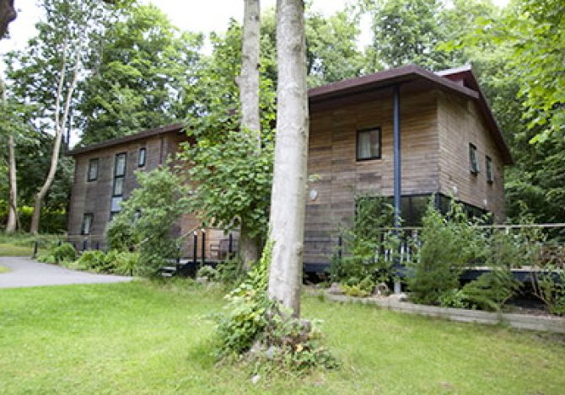
The centre does offer self-catering facilities for whole site bookings.
The main dining hall can seat 300+ with two smaller dining spaces catering for 30 and 40.
Each accommodation unit has access to a sitting room area where you have access to drinks making facilities.
Some sitting rooms have TVs. The centre has a fully fitted disco room.
The site has extensive wifi access

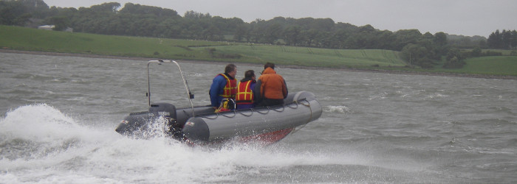
Powerboating
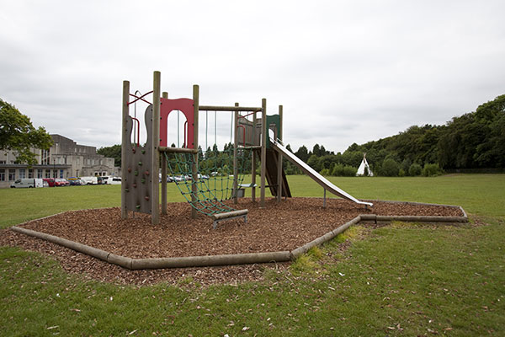
Low ropes
Kingsway Centre (Dearne Valley)
Kingswood offers a complete educational and adventure activity programme for young people across the UK and around the world; an experience that aids personal development, teaches key life-skills and helps build confidence and self-belief.
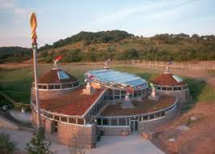
With stimulating environments, state of the-art facilities and highly qualified instructors, we can work with you to go beyond classroom teaching and textbook theory. Accelerated learning by doing and the ultimate adventure activity experience; a chance to enhance education, put theory into practice and encourage independence, self-awareness and teamwork every day.
Activities include:
- Outdoors: State of the art activity park with challenging apparatus including high and low ropes, zipwire and climbing
- Indoors: Giant indoor sports hall for climbing, fencing, archery, sport and team building activities, plus a laser zone
- Watersports: Purpose built watersports lake and adjacent River Don for raft building, kayaking and canoeing
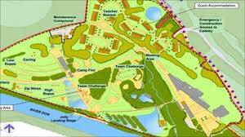Map of grounds
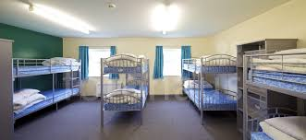Accommodation block
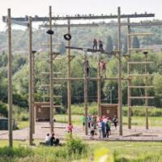
High ropes
Formerly the Earth Centre, one of the millennium commission projects, Dearne Valley opened its doors as the new Kingswood centre in 2012. Following a multi-million pound investment programme, Dearne Valley is our most environmentally sustainable centre, complete with one of Europe’s largest solar panels and an on-site waste recycling plant.
With all programmes tailored to help you meet your objectives, and unlimited help and guidance available every step of the way, at Kingswood we can provide that perfect blend of excitement, creative learning and adventure to meet your needs and requirements.
Red Ridge Outdoor Activity Centre
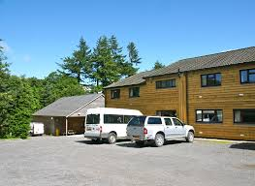
Red Ridge Centre stands in its own grounds, several miles from the small village of Cefn Coch, 16 miles from the Welsh Market town of Welshpool, Mid Wales.
Available activities include: Hill Walking, Archery, Caving, Climbing Wall, High Ropes, Rock Climbing, Orienteering, Kayaking, Abseiling, Paddle Boarding, Canadian Canoeing, Log Tower and many others.
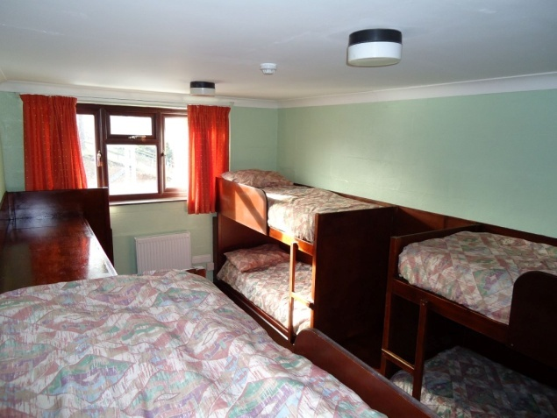

The centre has provided specialist outdoor education courses to Primary and Secondary school children for over 35 years, and is licensed to do so by the Adventure Activities Licensing Service (AALS).

Much of our work is with Special Schools, College Special Needs Groups and Voluntary Groups. Situated in the beautiful hills of Mid-Wales we are easily accessible to guests from most parts of England and Wales. We encourage the belief that all of us have a much greater potential than we would believe, and we seek to emphasise the positives and minimise the negatives
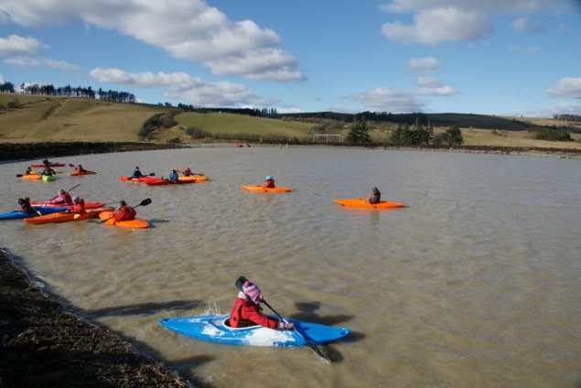
The sessions are led by experienced and qualified staff who, with their personal skills, patience, respect and good sense of humour will do their utmost to give everyone a chance to achieve
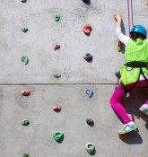
Climbing Wall
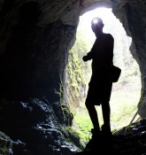
Caving
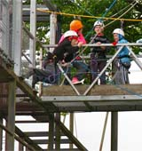
Climbing
Bendrigg Lodge
The Bendrigg Trust is an activity centre that provides group residential courses for disadvantaged people with special needs and disabilities.
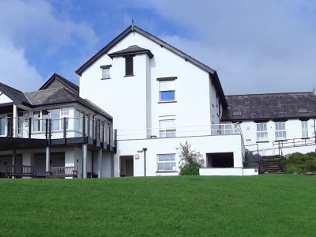
Activities at Bendrigg include: Indoor climbing and abseiling, outdoor climbing and abseiling,onsite caving, archery, offsite caving, canoeing, cycling, fell walking, gorge walking, orienteering, camping, archery, tube sliding, art, sensory room, zip wire, ropes course, sensory swing, bushcraft, sailing and night time activities.
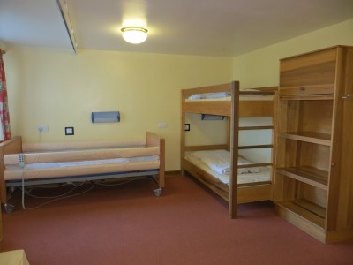
Bendrigg Trust is situated within 15 acres of beautiful grounds between the Lake District and Yorkshire Dales National Parks. With a variety of habitats including fields, woodlands and a tarn, Bendrigg is truly a special place. The grounds are home to many of our activities including zip wire, tube slide, orienteering and ropes courses as well as sculpture trails and a musical instrument garden created by our Artist in Residence. Groups can enjoy open-air campfires on an evening or take shelter with a log fire in our yurt or teepee.
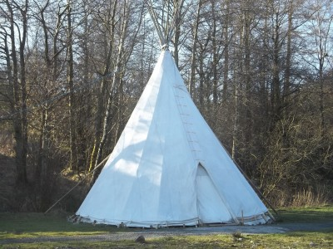
Day activities are a great choice for local groups or those who wish to sample our facilities and activities before committing to a residential trip. We offer the same flexibility as our residential courses with half or full-day courses available and a wide range of on and off-site activities. Regular day activities are the perfect way to build self-confidence and team work within your group, introduce you to new activities or simply just enjoy a fun day out
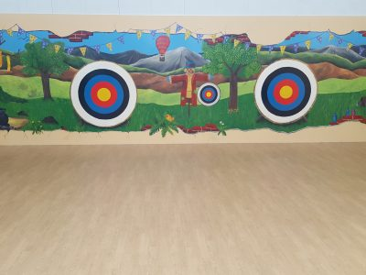
Archery in sports hall
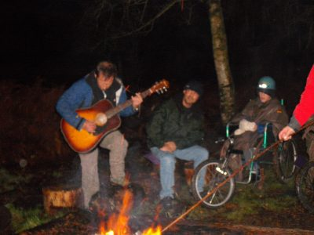
Night time activities
Appendix 2
Residentials Resource Pack

Medical Form

New Hey Road
Wirral
CH49 5LE
0151 641 8810
schooloffice@foxfieldschool.co.uk

Headteacher: Mr André Baird B.Ed.,M.Sc
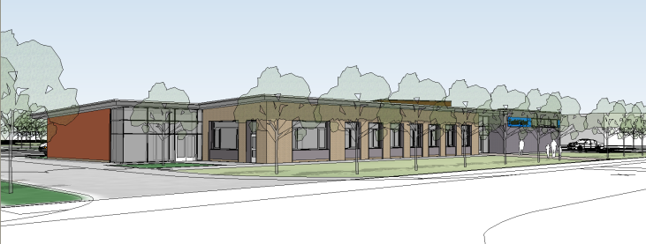

Form EV5

EDUCATIONAL VISIT (EV) MEDICAL INFORMATION

Visit to: ________________________________________________________________

Date(s):______________________________________

- I agree to (name of pupil)____________________________of ( Class ……… ) taking part in the visit and in the activities described.

- I agree to impress upon him/her the necessity to behave responsibly and to help the leaders to ensure the safety of everyone on the visit.

- I am aware that the school has detailed procedures for the planning, organisation and safe running of educational visits details of which I can obtain from school. I am also aware that the school’s educational visits are always well organised with a particular attention paid to health and safety. I understand that there can be no absolute guarantee of safety, but appreciate that the school leaders of the visit retain the same legal responsibility for pupils as they have in school and will do everything that is reasonably practicable to ensure the safety of everyone on the visit.

- Medical

- Does he/she have any condition requiring medication Yes/No

Give details:

b) Does he/she have any special dietary requirements? Yes/No

Give details:

c) Has your son/daughter been in contact with any contagious or infectious diseases,
or suffered from a contagious or infectious disease in the last four weeks? Yes/No

Give details:

d) Does your son/daughter have any allergies? Yes/No

Give details:

e) When did your son/daughter last have a Tetanus injection? Date: ____________

- Declaration:
I agree to inform the group leader of any change in medical condition, and I give consent to the administration of prescribed medication. I agree to the administration of blood transfusions as may be considered necessary by medically qualified persons, and any first aid deemed necessary, during the visit. The group leader will contact parents/guardians in the event of any accident

- Insurance Declaration:

I am aware that Public Liability insurance cover is provided by the school and I understand the limitations of the cover. I will take out any extra cover I consider necessary.
- Finance:

I understand that payment of any costs may be made by instalments or as a lump sum

- Hazardous activities:

I understand the nature of the potentially hazardous activities and have appreciated that the school has made and will make every effort to ensure the safety of pupils during these activities, and that the school has obtained all the required safety management certification, and instructors’ qualifications, for the activities.

- Swimming (if applicable):

My son/daughter:

Is confident in a pool Yes/No
Wears armbands Yes/No

I consent to my son/daughter taking part in water activities in a swimming pool Yes/No

- Emergency contact arrangements:

I have read and understood the contact arrangements, and have provided an emergency contact number below.
- Contacts:

Contact telephone numbers:

Work: Home: Mobile:

Home address:

Alternative emergency contact:

Name: Telephone number(s)
Address:

Name of family doctor: Telephone Number:
Address:

Signed: ____________________ Name of pupil: _____________________class group_____

One copy of this form must be left at the school. The leader must take one copy of this form on residential

Appendix 3
Night time routines

New Hey Road
Wirral
CH49 5LE
0151 641 8810
schooloffice@foxfieldschool.co.uk

Headteacher: Mr André Baird B.Ed.,M.Sc

Date: …………………………………………

Residential Venue: …………………………………………….
Residential Date: ……………………………………………….

Name of Pupil: ……………………………………………………

Dear Parent

Could you please let me know of any night time/morning routines your son/daughter may have, for example, do they prefer a shower or bath in the evening or in the morning.
Please give any information that we might find helpful. Thanks.

Yours Sincerely

Group Leader

Details of Routines for ……………………………………….(name of pupil)

………………………………………………………………………………………………………………………………………………………………………………………………………………………………………………………………………………………………………………………………………………………………………………………………………………………………………………………

Appendix 4
Suggested Kit List

New Hey Road
Wirral
CH49 5LE
0151 641 8810
schooloffice@foxfieldschool.co.uk
Headteacher: Mr André Baird B.Ed.,M.S

c

SUGGESTED KIT LIST FOR FIVE DAY, FOUR NIGHT RESIDENTIAL
4 t- shirts
4 pairs socks
4 changes of underwear (minimum)
4 sweatshirts/t- shirts
4 pairs tracksuit pants (minimum)
2 pairs shoes/trainers suitable for walking
1 hand towel
1 bath towel
Sun hat ALL ITEMS MUST BE CLEARLY
Sun cream LABELLED TO ENSURE THEIR
Wash kit SAFE RETURN
Sanitary items
Pyjamas
Slippers
Outer jacket/waterproof
Gloves
Camera
Personal stereo
Favourite video/book/toy etc.
Pocket money (suggest £10)
Torch
For Old School Lodge; Sleeping bag
All items must be clearly marked to ensure their safe return.
Appendix 5
Consent and Medical Form 2015

Please use this form to monitor consent/med forms
NAME CONSENT MED FORM OTHER
CLASS ________ CENTRE ______________________
GROUP LEADER ___________________DATE ________
STAFF ________________________________________

