FOXFIELD SCHOOL

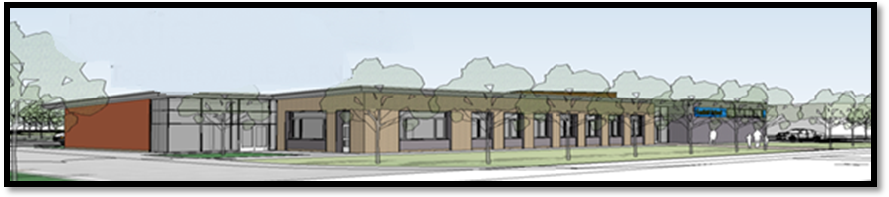

Mathematics
Curriculum Document

November 2018

WHOLE SCHOOL MATHEMATICS LEADER

Becky McBride

Key Stage 3 Mathematics at Foxfield

The Key Stage 3 Maths Curriculum at Foxfield School has been tailored around the requirements and guidelines which are set out in the National Curriculum guidelines for Mathematics. This covers areas of Number, Space Shape and Measures, Handling Data, Using and Applying Mathematics and Problem Solving and reasoning in Number. The Learning Objectives are derived from the Strategy and from the Foundation Stage Curriculum and are levelled from P1 to Level 3.

At Key Stage 3 the Maths curriculum has been designed to incorporate the following three elements into the functional skills lessons that pupils have per week:

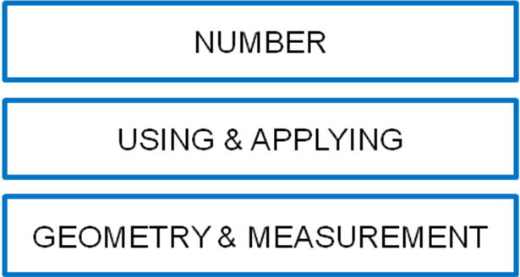

Number

This area of Maths lays the foundation for many other aspects of the curriculum and needs to be taught regularly and with repetition in order for progress to be made, consolidated and built upon. Pupils who progress at a good pace should be taught to use and apply these skills within other areas.
Pupils should learn mental fluency with whole numbers, counting and place value, this should involve working with numbers, words and the four operations. Pupils should work with practical resources.

Using and Applying

These particular elements of Maths are extremely important for the pupils at Foxfield as they provide life skills which, if acquired, will develop independence and help our students to better cope with real life situations in the outside world.
This area of learning includes seeking patterns, making connections, recognising relationships, counting, sorting and matching. Pupils are encouraged to use their skills and knowledge in these areas to solve problems and make connections across other areas of learning. They should apply their maths to a variety of routine and non routine problems and be given appropriate support to both fail and solve these problems in safe learning environments.
Lessons should use skills learnt in both the Number and Geometry and Measure aspects of Mathematics and focus on practical work.

Geometry & Measurement

This area is outlined on the ‘Focus Area Rota’ which incorporates six different topics that each class will cover in a year. Pupils will therefore encounter these topics three times during the three years of Key Stage 3. These areas are taught throughout the year but teachers can be flexible if the area can be taught alongside the cross curricular areas. It is intended that by using this approach, all areas of the National Curriculum for Mathematics will be addressed. This will ensure that all pupils will receive a broad and balanced maths curriculum which includes everyday living skills.

Spoken Language

The National Curriculum for maths reflects the importance of spoken language in pupils’ development across the whole curriculum – cognitively, socially and linguistically. The quality and variety of language that pupils hear and speak are key factors developing their mathematical vocabulary.
Pupils should be encouraged to develop their mathematical thinking through discussions.

Key Skills

Maths planning will also incorporate areas where basic key skills can be practised within the lesson. These will be split into P levels 3-4, 5-6 and 7-8.

PLTS

Mathematics planning will address the six different PLTS areas.
The areas are:

- Independent enquirers
- Creative thinkers
- Reflective learners
- Team workers
- Self managers
- Effective participators

Functional Skills

Functional skills are essential skills in English, mathematics and Computing that enable everyone to deal with the practical problems and challenges of life – at home, in education and at work. They are essential to all our lives. For example, they help us recognise good value deals when making purchases, in writing an effective application letter, or when using the internet to access local services or online banking. They are about using English, Mathematics and Computing in everyday situations.
Functional skills are a key to success. They open doors to learning, to life and to work. These skills are valued by employers and further education and are a platform on which to build other employability skills. Better functional skills can mean a better future - as learners or

Key Stage 3: Number Rota

 | AUTUMN 1 | AUTUMN 2 | SPRING 1 | SPRING 2 | SUMMER 1 | SUMMER 2
R1 | Counting and reading numbers | Place value:  Ordering and comparing numbers | Addition and subtraction;  More/less | Counting and reading numbers | Place value:  Ordering and comparing numbers | Addition and subtraction;  More/less
R2 | 1:1 correspondence | Counting and comparing quantities | Cause / effect  Sequencing, sorting | 1:1 correspondence | Counting and comparing quantities | Cause / effect  Sequencing, sorting
R3 | Counting, reading and writing numbers | Place value:  Ordering, comparing and sequencing numbers | Addition and subtraction  Multiplication and division | Counting, reading and writing numbers | Place value:  Ordering, comparing and sequencing numbers | Addition and subtraction  Multiplication and division
R4 | Counting, reading and writing numbers | Place value:  Ordering, comparing and sequencing numbers | Addition and subtraction  Multiplication and division | Data Handling & Problem Solving | Addition and subtraction  Multiplication and division | Fractions  Ratios  Percentages
R5 | Counting and reading numbers | Place value:  Ordering and comparing numbers | Addition and subtraction;  More/less | Counting and reading numbers | Place value:  Ordering and comparing numbers | Addition and subtraction;  More/less
R6 | Counting and reading numbers | Place value:  Ordering and comparing numbers | Addition and subtraction;  More/less | Counting and reading numbers | Place value:  Ordering and comparing numbers | Addition and subtraction;  More/less

 | AUTUMN 1 | AUTUMN 2 | SPRING 1 | SPRING 2 | SUMMER 1 | SUMMER 2
R1 | Geometry  Position and direction | Measurement:  Measuring Mass/ Capacity | Measurement:  Measuring Length / height | Measurement:  Reading time | Measurement:  Using Money | Geometry:  2D / 3D shapes
R2 | Geometry:  2D / 3D shapes | Geometry  Position and direction | Measurement:  Comparing Mass/ Capacity | Measurement:  Comparing Length / height | Measurement:  Sequence and time | Measurement:  Recognising Money
R3 | Measurement:  Recognising Money | Geometry:  2D / 3D shapes | Geometry  Position and direction | Measurement:  Mass/ Capacity | Measurement:  Comparing Length / height | Measurement:  Sequence and time
R4 | Measurement:  Sequence and time | Measurement:  Recognising Money | Geometry:  2D / 3D shapes | Geometry  Position and direction | Measurement:  Comparing Mass/ Capacity | Measurement:  Comparing Length / height
R5 | Measurement:  Measuring Length / height | Measurement:  Reading time | Measurement:  Using Money | Geometry:  2D / 3D shapes | Geometry  Position and direction | Measurement:  Measuring Mass/ Capacity
R6 | Measurement:  Measuring Mass/ Capacity | Measurement:  Measuring Length / height | Measurement:  Reading time | Measurement:  Using Money | Geometry:  2D / 3D shapes | Geometry  Position and direction
Key Stage 3: Geometry & Measure Rota
Key Stage 4 Mathematics at Foxfield

The Key Stage 4 Maths Curriculum at Foxfield continues to develop and build upon the skills and concepts learnt in key stage 3.
Adaptations have been made where necessary and all objectives have been closely considered in terms of their relevance and suitability and the current P levels which all pupils are assessed against when entering Foxfield School.

At Key Stage 4 the Maths curriculum has been designed to incorporate the following three elements into the three maths lessons that pupils have per week:

Qualifications
Pupils study a variety of areas of maths over a two year rolling programme. They aim to achieve a maths qualification in either the ASDAN Personal Progress units (Entry 1). From eight qualifications covered in Key Stage 4, four of the qualifications have a Mathematics focus.

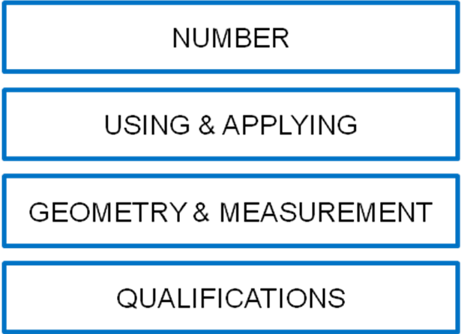

Key Stage 4: Number Rota

 | AUTUMN 1 | AUTUMN 2 | SPRING 1 | SPRING 2 | SUMMER 1 | SUMMER 2
G1 | Counting and reading numbers | Place value:  Ordering and comparing numbers | Addition and subtraction;  More/less | Counting and reading numbers | Place value:  Ordering and comparing numbers | Addition and subtraction;  More/less
G2 | Counting, reading and writing numbers | Place value:  Ordering and comparing numbers | Addition and subtraction;  More/less | Counting and reading numbers | Place value:  Ordering and comparing numbers | Addition and subtraction;  More/less
G3 | Counting and reading numbers | Place value:  Ordering and comparing numbers | Addition and subtraction;  More/less | Counting and reading numbers | Place value:  Ordering and comparing numbers | Addition and subtraction;  More/less
G4 | Counting, reading and writing numbers | Place value:  Ordering, comparing and sequencing numbers | Addition and subtraction  Multiplication and division | Data Handling & Problem Solving | Addition and subtraction  Multiplication and division | Fractions  Ratios  Percentages

Key Stage 4: Geometry & Measure Rota

 | AUTUMN 1 | AUTUMN 2 | SPRING 1 | SPRING 2 | SUMMER 1 | SUMMER 2
G1 | Measurement:  Measuring Mass/ Capacity | Measurement:  Measuring Length / height | Measurement:  Reading time | Measurement:  Using Money | Geometry:  2D / 3D shapes | Geometry  Position and direction
G2 | Geometry  Position and direction | Measurement:  Measuring Mass/ Capacity | Measurement:  Measuring Length / height | Measurement:  Reading time | Measurement:  Using Money | Geometry:  2D / 3D shapes
G3 | Geometry:  2D / 3D shapes | Geometry  Position and direction | Measurement:  Comparing Mass/ Capacity | Measurement:  Comparing Length / height | Measurement:  Sequence and time | Measurement:  Recognising Money
G4 | Measurement:  Recognising Money | Geometry:  2D / 3D shapes | Geometry  Position and direction | Measurement:  Mass/ Capacity | Measurement:  Comparing Length / height | Measurement:  Sequence and time

Post 16 Maths at Foxfield

Foxfield caters for students until the age of nineteen who therefore spend three years with us as part of the Post 16 department. At 16+ there are at least two descreet maths lessons per week. One lesson is a Functional Skills / Number lesson, whilst the other is either an Asdan Personal Progress Qualifications or a measurement lesson. This lesson is designed to incorporate a variety of Maths skills drawing on the pupil’s past attainments and applying them to everyday situations.

The main aims within the Post 16 department are to encourage independence and to develop independent living skills as far as possible. The Mathematics programme at Post 16 has been structured in such a way that it is entirely aimed to focus on the development of mathematical skills for personal, vocational and social application , whilst also continuing to develop, build upon and consolidate the key skills taught during Key Stage 3 and 4.

Many of the areas covered at 16+ are experienced in a cross curricular fashion through the Independent Living Skills curriculum.

All areas are taught during each year at Post 16 in order to provide continuity, repetition and consolidation of skills and knowledge. However the medium through which these areas are delivered and experienced is varied throughout the three year programme to ensure broad access to a range of different everyday situations and amenities. Teachers of Post 16 classes will plan to help pupils access the maths curriculum through learning opportunities and situations which encompass the local and wider community including Independent Living Skills.

Post 16: Number Rota

 | AUTUMN 1 | AUTUMN 2 | SPRING 1 | SPRING 2 | SUMMER 1 | SUMMER 2
O3 | Recognise numbers | Counting and ordering numbers | Addition and subtraction | Recognise numbers | Counting and ordering numbers | Addition and subtraction
B1 | Recognise numbers | Counting and ordering numbers | Addition | Recognise numbers | Counting and ordering numbers | Addition
B2 | Counting, reading and writing numbers | Place value:  Ordering, comparing and sequencing numbers | Addition and subtraction  Multiplication and division | Counting, reading and writing numbers | Data Handling & Problem Solving | Addition and subtraction  Multiplication and division
B3 | Counting, reading and writing numbers | Place value:  Ordering, comparing and sequencing numbers | Addition and subtraction  Multiplication and division | Counting, reading and writing numbers | Place value:  Ordering, comparing and sequencing numbers | Addition and subtraction  Multiplication and division
B4 | Counting, reading and writing numbers | Place value:  Ordering, comparing and sequencing numbers | Addition and subtraction  Multiplication and division | Data Handling & Problem Solving | Addition and subtraction  Multiplication and division  numbers | Fractions

Post 16: Geometry & Measurement Rota

 | AUTUMN 1 | AUTUMN 2 | SPRING 1 | SPRING 2 | SUMMER 1 | SUMMER 2
O3 | Measurement:  Recognising Money | Geometry:  2D / 3D shapes | Geometry  Position and direction | Measurement:  Comparing Mass/ Capacity | Measurement:  Comparing Length / height | Measurement:  Sequence and time
B1 | Measurement:  Measuring Length / height | Measurement:  Reading time | Measurement:  Using Money | Geometry:  2D / 3D shapes | Geometry  Position and direction | Measurement:  Measuring Mass/ Capacity
B2 | Measurement:  Measuring Mass/ Capacity | Measurement:  Measuring Length / height | Measurement:  Reading time | Measurement:  Using Money | Geometry:  2D / 3D shapes | Geometry  Position and direction
B3 | Geometry  Position and direction | Measurement:  Measuring Mass/ Capacity | Measurement:  Measuring Length / height | Measurement:  Reading time | Measurement:  Using Money | Geometry:  2D / 3D shapes
B4 | Geometry:  2D / 3D shapes | Geometry  Position and direction | Measurement:  Comparing Mass/ Capacity | Measurement:  Comparing Length / height | Measurement:  Sequence and time | Measurement:  Recognising Money

Opportunities for Computing

Information and Communication Technology is used throughout the teaching and learning of Maths at Foxfield. It is seen not only to be the work carried out in maths on computers but also lessons involving digital technology, sensory and soft play room technology, digital cameras and photocopying etc.

The following list describes the ICT software and hardware that is used to develop the teaching and learning of maths at Foxfield School.

Software
- There are a number of maths software packages installed on the internal system
- Touch software
- Switch software
- Internet & websites
- On screen grids such as clicker 4
- Symbol software

Hardware
- iboard
- Sensory trolley
- Ipad
- Beebots

Maths of The Day
To support planning and Mathematics knowledge of teachers at Foxfield School we have signed up to a Mathematics package called ‘Maths of The Day’. This is a useful resources to aid planning and resources while encouraging lessons to incorporate practical maths lessons that may often take place in an outside environment.

Assessment of Mathematics

Both formal and informal assessment of Mathematics is carried out at Foxfield School. Staff are encouraged to gather feedback from support staff during and at the end of maths lessons. Formal assessment is completed twice annual for all pupils in all three areas of mathematics; Number, Using and Applying and Geometry and Measure.

In addition, Key stage 4 and Post 16 pupils complete ASDAN Personal Progress Mathematics based qualifications which are regularly internally and externally moderated.

