School Security Policy
2018
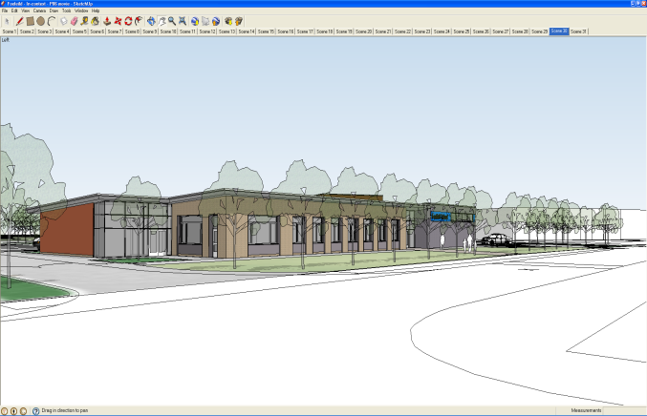
Foxfield School has a number of policies relating to Security and Safeguarding Children as can be seen below:
- Health and Safety Policy
- Visitors Policy
- Lone Workers Policy
- CCTV Policy
- Staff Induction Policy
- Financial Procedures Policy
- Child Protection and Safeguarding Policy
- Assorted Risk Assessments
- Fire Log and Procedures
- Supervision Policy
- Dealing with extremism and radicalisation
School alarms and emergency lighting are checked on a regular basis. A service level agreement exists between the school and Syncro who installed the systems so that regular services are assured.
The school also pays for an out of hours patrol service who

provide services as outlined in their Operational Procedures and Guidelines (See WESCOM).
Foxfield School Access and Egress
At Foxfield we are fortunate enough to have a magnetic locking system which limits access and egress to anyone who does not have a swipe card. Therefore access by anyone managing to enter the school for the purpose of causing harm would be restricted. If a person managed to force their way into the foyer they should not be able to access the main body of the school
All fire doors to the car park can only open from inside the building and remain closed all day. Access via the pupil entrance would only be possible if someone had managed to scale the fence and gates at the entrance to the playground. This is highly unlikely as the fence is designed to make climbing it a near impossibility. In the event of an intruder managing to enter the main body of the school we would then enforce a dynamic lockdown procedure (See below).
This means that an intruder will not be able to access any of the key stage corridors or specialist rooms without a swipe card. The gym can be locked with the key from the inside.
Dealing with a bomb threat
Following a number of malicious hoax communications to schools around the country in 2015/16 it is important to be vigilant but not alarmed as these calls are designed to cause panic and disruption.
Most bomb threats are made over the phone with the overwhelming majority being hoaxes. It is probable that the people most likely to deal with a call of this nature would be the office staff, the Head teacher or Deputy and so all have had training in dealing with this situation.
When receiving a call of this nature there are six main points to remember:
- Try to stay calm and listen
- Obtain as much information as possible
- Put the phone on loudspeaker so that the conversation can be recorded from a Dictaphone or other device
- When the caller rings off dial 1471 to see if you can get their number (if your phone allows you to do this)
- Report the incident to management and notify police
- Evacuate the school as you cannot afford to take chances. You can then take advice from authorities as a search of the building may need to be made.
(See bomb threat checklist appendix 1)
Search planning and guidance
A visual inspection is made of the premises by the caretaker on a daily basis. Any problems with the building are reported before 8am to the Head teacher or in his absence to the Deputy.
Evacuation Planning
In the event of the need to evacuate the building the same procedure as in the case of fire should be followed. Leave the building by the nearest exit and make your way around the perimeter of the building. If this evacuation is taking place due to the possibility of an explosive device at an unknown and unspecified area of the building it would not be safe for a swimming group to stand outside the pools and wait for the all clear as the device could be in their vicinity. If this is the case the group must be led by staff around the front of the building on the pavement so as to put some distance between themselves and the building and to the assembly point by the minibus pen via the playground.
All staff and pupils will assemble by the minibus pen. If it is deemed unsafe to re-enter the building then arrangements will be made to access Woodchurch High School by taking the path down the side of the adventure playground and accessing Woodchurch High via the gate in the pathway between the two schools.
Dynamic lockdown
In the event of an intruder being spotted on site a Tannoy announcement ‘LOCKDOWN LOCKDOWN LOCKDOWN’ will be made. On hearing this
staff should endeavour to get themselves and any pupils into the nearest room (providing it has a magnetic lock). Once in the room stand away from the door and try to stay out of sight (preferably in a breakout room if there is one). If you are in the gym lock the door from the inside and make sure that the door to the music room is also locked.
Stay in the room until you hear the all clear Tannoy announcement ‘ABANDON LOCKDOWN ALL CLEAR’
Employee vigilance
All visitors to Foxfield School should be given a badge to wear if they do not have the authority badges or NHS cards. This should be the case for ALL visitors. It is the duty of all staff members to challenge anyone in school not displaying a badge. If a badge has fallen off they need to return to reception to get a new one.
Closed circuit TV
Foxfield School is equipped with a closed circuit TV system which shows most areas of the school and classrooms. It is also possible to track people in the grounds and going past the school on the pavements, the road and the pathway between Foxfield and Woodchurch High School. Permission to view footage saved by the cameras must be given by the Head teacher or Deputy and a log must be filled in stating what has been viewed. This is then signed and dated.
Screening mail and deliveries
A log is kept of all packages delivered to school and these have to be signed for. Any suspicions should be reported to management and not kept to oneself.

Appendix 1
Bomb threat checklist
Actions to be taken:
- Switch on speaker phone so as to record conversation
- Tell caller where you are answering from
Questions to ask
- Where is the bomb right now?
- When is it going to explode?
- What does it look like?
- What will cause it to explode?
- Did you place the bomb?
- Why?
- What is your name?
- What is your address?
- What is your telephone number?
Record time of call
- Where automatic number reveal is available record number shown
- Try 1471 to see if can get a number (if your phone allows you to do this)
- Contact the police (Record time informed)
Once the caller has hung up and the police informed note
- Date and time of call
- Length of call
- Number at which call was received i.e. extension number
- Sex of caller
- Approximate age
- Nationality
Language
- Accent?
- Were they well spoken?
- Were they rational?
- Were they offensive?
- Were they recorded?
- Were they incoherent?
Callers Voice
- Was the voice calm?
- Were they crying?
- Did they clear their throat?
- Were they angry?
- Were they nasal?
- Were they slurred?
- Were they excited?
- Was there a stutter?
- Was there a lisp?
- Type of Accent (if any)?
- Was the voice slow?
- Was the voice disguised?
- Was the voice rapid?
- Was the voice deep?
- Was the voice hoarse?
- Was there any laughter?
- Was the voice familiar?
Background sounds
- Street noises?
- House noises?
- Animal noises?
- Crockery?
- Motors?
- Clear?
- Other voices?
- Static?
- PA System?
- Booth?
- Music?
- Factory Machinery?
- Office Machinery?
- Other (Specify)?
Any other remarks
__________________________________________________________________________________________________________________________________

Signature:
__________________________
Print Name:
__________________________
Date:

