2 | RA 029 – Out of school provision National Restrictions Addendum v2 | RISK ASSESSMENT  RECORDING FORM

Location or School  Address: Foxfield School | Date assessment  Undertaken 16/11/2020 | Assessment undertaken  by : Jeanne Fairbrother and Paul Howley
Activity or situation:  Out of school provision - National Restrictions 5th November – 2nd December 2020 | Review  date : Weekly review or as appropriate for the activity | Signature: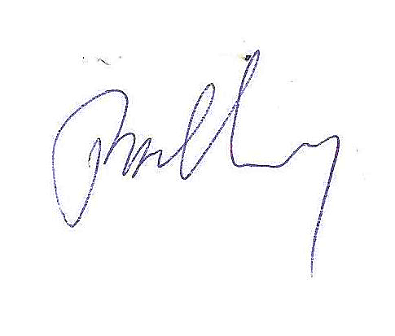

These are a temporary set of measures which sit alongside our latest version RA 029 Full opening of school.

New National Restrictions came into force on Thursday 5 November until 2nd December 2020. Revised 16th November 2020
This addendum reflects new control measures for Out of school provision in the following areas which will be affected during the period of the New National Restrictions:
- use of face coverings
- transport
- clinically extremely vulnerable staff & children
- clinically vulnerable staff & children
- wraparound provision and extra-curricular activity
- music, dance & drama
- physical activity in schools
- residential care

1) Hazard / Activity | 2) Who can be harmed and how? | 3) What controls exist to reduce the risk?  Have you followed the hierarchy of controls (eliminate, substitute etc) | Risk Score  Consequence  X Likelihood | 4) Any further action;  This should be included in the action plan on overleaf
Face coverings – failure of visitors, staff to wear a face covering according to guidance | Staff, pupils, parents, visitors increased risk of transmission of Coronavirus (COVID 19) | - Face coverings are used where teaching, training or activity is taking place in an area in which children aged 11 and over or staff are likely to come into contact with other members of the public (complying with relevant coronavirus (COVID-19) sector guidance).  - Face coverings are worn by adults and children aged 11 and above when moving around the premises, outside of classrooms or activity rooms, such as in corridors and communal areas where social distancing cannot easily be maintained. | 3 X 2 = 6
Transport- increased risk of transmission failing to follow guidance | Staff, pupils, parents, visitors increased risk of transmission of Coronavirus (COVID 19) | - School follows the transport guidance when arranging transport to and from schools from the autumn term.  - Children and young people aged 11 and over must wear a face covering on public transport. Face coverings should also be worn by pupils in year 7 and above when travelling on dedicated school transport to secondary school or college. This does not apply to those who are exempt.  - Travel in or out of local areas should be avoided, and parents, carers and staff should look to reduce the number of journeys they make - but travelling to deliver and access education is still permitted.  - Staff, children and their parents and carers are encouraged to walk or cycle when travelling to and from school where this is possible, and to plan ahead and avoid busy times and routes on public transport. This will allow social distancing to be practised. | 3 X 2 = 6
Visitors to the setting increasing the risk of transmission | Staff, pupils, parents, visitors increased risk of transmission of Coronavirus (COVID 19) | - The setting will restrict all visits to the setting to those that are absolutely necessary. | 3 X 2 = 6
Clinically extremely vulnerable Children at increased risk of contracting Covid 19 | Staff, pupils, parents, visitors increased risk of transmission of Coronavirus (COVID 19) | - Most young people originally identified as clinically extremely vulnerable no longer need to follow original shielding advice.  - Parents are advised to speak to the young person’ GP or specialist clinician if they have not already done so, to understand whether their child should still be classed as clinically extremely vulnerable.  - Those young people whose doctors have confirmed they are still clinically extremely vulnerable are advised not to attend childcare or nursery during the period this advice is in place.  - Where a meeting with a GP or specialist clinician has not taken place, the public health advice is that the child is still clinically extremely vulnerable and should not attend school. In these situations, schools must offer clinically extremely vulnerable children access to remote education.  - Young people who live with someone who is clinically extremely vulnerable, but who are not clinically extremely vulnerable themselves, should still attend education or childcare.  - Parents of a clinically extremely vulnerable young person have received a letter confirming this advice. | 3 X 2 = 6
Clinically extremely vulnerable  Staff Children at increased risk of contracting Covid 19 | Staff, pupils, parents, visitors increased risk of transmission of Coronavirus (COVID 19) | - Those individuals who are clinically extremely vulnerable are advised to work from home and not to go into work. Individuals in this group will have been identified through a letter from the NHS or from their GP and may have been advised to shield in the past. Staff should talk to their employers about how they will be supported, including to work from home where possible, during the period of national restrictions.  - All other staff should continue to attend work, including those living in a household with someone who is clinically extremely vulnerable. | 3 X 2 = 6
Clinically vulnerable staff and children at increased risk of contracting Covid 19 | Staff, pupils, parents, visitors increased risk of transmission of Coronavirus (COVID 19) | - Staff and children who are clinically vulnerable or have underlying health conditions but are not clinically extremely vulnerable should continue to attend school in line with current guidance.  - School will carry out a risk assessment on each member of staff identified as clinically vulnerable | 3 X 2 = 6
Music, dance and drama  Increased risk of transmission from not following guidance | Staff, pupils, parents, visitors increased risk of transmission of Coronavirus (COVID 19) | - Music, dance and drama can be undertaken in school so long as safety precautions are undertaken. Advice is provided in the full opening guidance for schools. | 3 X 2 = 6
Provision of before and after school provision increasing risk of spread of coronavirus | Staff, pupils, parents, visitors increased risk of transmission of Coronavirus (COVID 19) | - The club continues to operate for face-to-face provision during this period for parents to access :  - work or search for work  - undertake training or education  - The club will make parents aware that the setting should only be accessed for the essential purposes outlined. | 3 X 2 = 6 | No clubs are operating at present in the Foxfield School setting
Sport and physical education Increased risk of transmission from not following guidance | Staff, pupils, parents, visitors increased risk of transmission of Coronavirus (COVID 19) | - School has the flexibility to decide how physical education, sport and physical activity will be provided whilst following the measures in their system of controls.  - Only sports whose national governing bodies have developed guidance under the principles of the government’s guidance on team sport and been approved by the government are permitted.  - School will only provide team sports listed on the return to recreational team sport framework.  - Competition between different schools should not take place, in line with the wider restrictions on grassroots sport.  - Pupils will be kept in consistent groups and sports equipment thoroughly cleaned between each use by different individual groups.  - Outdoor sports are prioritised where possible, and large indoor spaces used where it is not, maximising natural ventilation flows (through opening windows and doors or using air conditioning systems wherever possible), distancing between pupils and paying scrupulous attention to cleaning and hygiene.  - External facilities will be used in line with government guidance for the use of, and travel to and from, those facilities.  - School will not work with external coaches, clubs and organisations for curricular activities  - Extra-curricular activities (that is, before and after school clubs) are no longer available  - See also https://www.gov.uk/guidance/working-safely-during-coronavirus-covid-19/providers-of-grassroots-sport-and-gym-leisure-facilities  - School remains open and children can participate in PE and sport where it is part of the curriculum or part of the core timetable of the school.  - School has reviewed all organised children’s/pupils sport outside school activity and ceased provision. | 3 X 2 = 6

Risk Rating | Action Required
17 - 25 | Unacceptable – stop activity and make immediate improvements
10 – 16 | Tolerable – but look to improve within specified timescale
5 – 9 | Adequate – but look to improve at review
1 – 4 | Acceptable – no further action but ensure controls are maintained
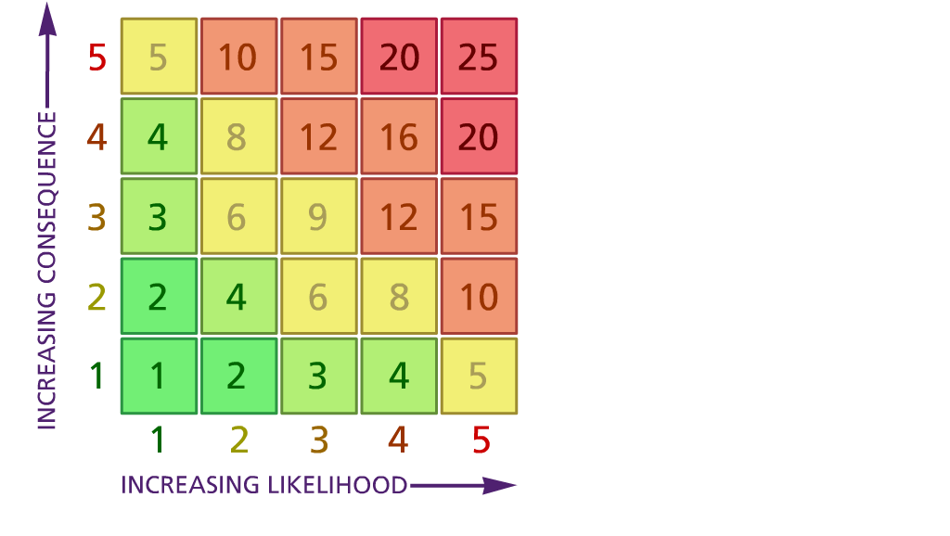

(1) List hazards something with the potential to cause harm here
(2) List groups of people who are especially at risk from the significant hazards which you have identified
- List existing controls here or note where the information may be found. Then try to quantify the level of risk the likelihood of harm arising that remains when the existing controls are in place based on the number of persons affected, how often they are exposed to the hazard and the severity of any consequence. Use this column to list the controls that you might take and develop all or some of that list into a workable action plan. Have regard for the level of risk, the cost of any action and the benefit you expect to gain. Agree the action plan with your team leader and make a note of it overleaf. If it is agreed that no further action is to be taken this too should be noted.

Likelihood: Consequence:

5 – Very likely 5 – Catastrophic

4 – Likely 4 – Major
3 – Fairly likely 3 – Moderate

2 – Unlikely 2 – Minor

1 – Very unlikely 1 – Insignificant

(5) ACTION PLAN
Action required: | Responsible person | Completion date
Action plan agreed with (signature) 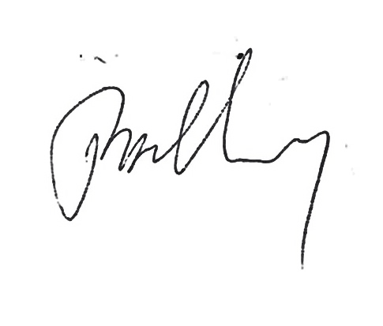 Date:16/11/2020

